Ancient Astronomy Online Field Trips Name _________________________________________ Period ___
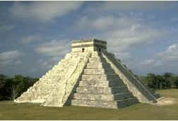

Ancient Astronomy – Ancient cultures not only made up the constellations and mythology that you are investigating in your constellation project, but they also were very diligent watchers of the sky. They tracked the Sun, moon and planets across the sky and through time, and were very precise in their measurements. Visit the following websites to learn about a few sites where we still can see the remains of ancient observatories. Links are on our class website (Ancient Astronomy Online Field Trips)
1. Ancient Observatories – The Exploratorium Museum’s exhibit about Chaco Canyon and Chichen Itza. Enter the Broadband site. Choose one of the two sites to explore. For each section of the exhibit write a reflection – what surprised you; what was interesting; what was weird, etc. The sections of the exhibit are listed at the bottom of the window (Chaco Canyon – Canyon; Observation; etc; Chichen Itza – Chichen Itza; Alignments; etc)

2. Mystic Places – We are looking at this site for its 10 satellite pictures, not the mystical aspect. Scroll down through the images and choose three or four sites to investigate. Explain what you looked at and what you found interesting.

3. Choose one of the remaining three links. Browse through it. Describe the information or images you look through

