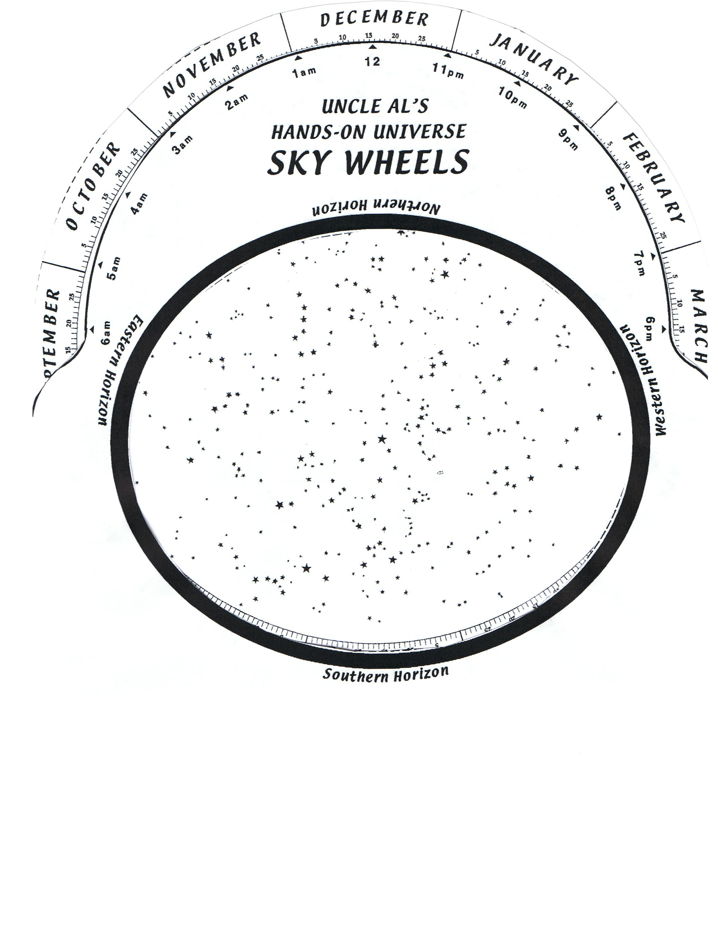
Name: ________________________

100. Identify on the star chart above the following constellations and their brightest stars:

Winter
Orion (Betelgeuse, Rigel, [Alnitak, Alnilam and Mintaka]), Canis Major (Sirius), Canis Minor (Procyon), Gemini (Pollux, Castor), Auriga (Capella), Taurus (Aldebaran, the Pleaides)

Ursa Major, Ursa Minor, Cassiopeia

