Spring Constellations
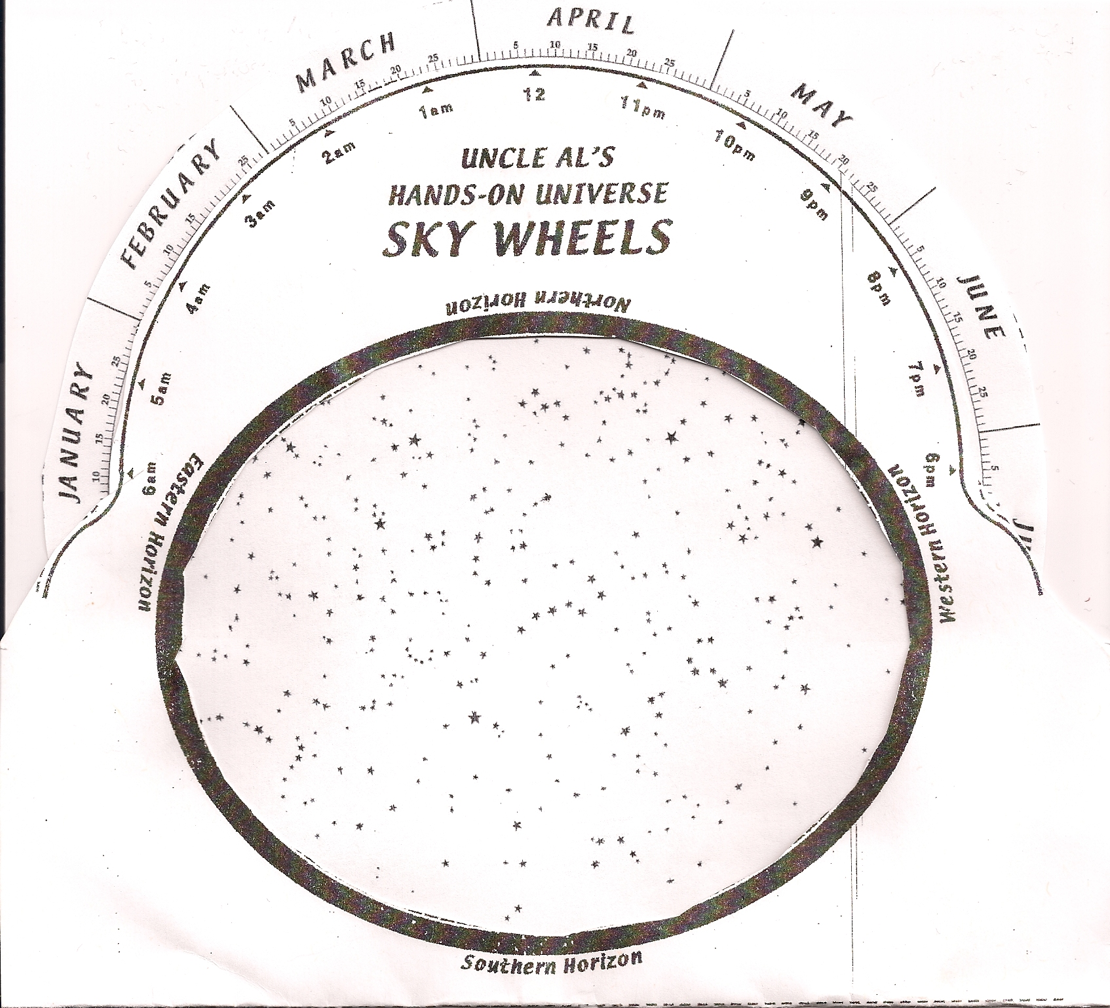

Identify on the chart the following constellations:
Ursa Major, Ursa Minor, Bootes, Virgo, Leo

Identify the following stars on the chart:
Polaris, Arcturus, Spica, Regulus

