Part 3: Reading Guide SEED Magazine Article
Up the Cosmic Distance Ladder: What We Know by Lee Billings

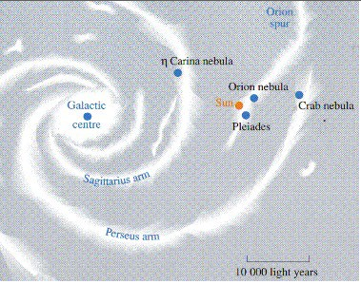
- Below is an image of our Milky Way Galaxy. Find our location. The article says we are contained in the Orion spur, not even in a spiral arm of the galaxy. The 2nd picture is an image of the night sky with Sagittarius’ outline (nicknamed the Teapot). When we look up at the night sky where are the stars we are seeing? How far out into the Milky Way can we see? What do you think we are looking at when we say we are looking at the Milky Way when we look at the hazy white areas of the sky near Sagittarius?
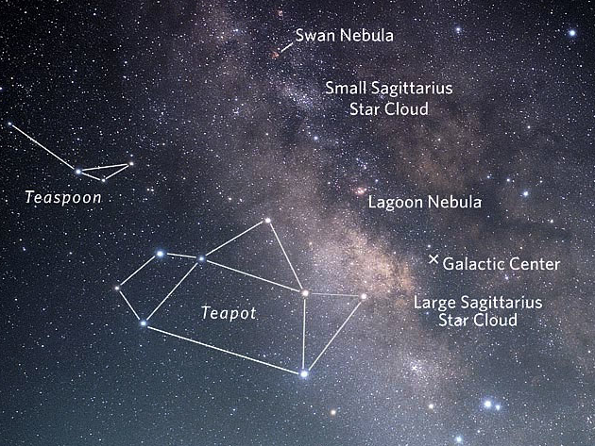
- Eratosthenes was born in 276 BC and died in 194 BC. Aristarchus lived from 310 – 230 BC. How long was it before the theory of heliocentrism was revived? What kind of things changed in human history during that time? We were stagnant or growing our knowledge base?

- Kepler published his three laws of planetary motion in 1609 and Cassini and Richer found the parallax shift of Mars to determine its distance in 1673. Why do you think this timeframe is so much shorter than the timeframe of the first public discussion of the theory of heliocentrism until its widespread acceptance through Copernicus?

- Many observatories, like The University of Chicago’s Yerkes Observatory, have large collections of images of stars - thousands of pictures and negatives of stars going back 50-100 years. After reading the Stars section, why might these collections be a good thing and not a ‘white elephant’?

- The mystery of the nebulae was a great debate between astronomers during the early 1900s. Cepheid variables, one type of standard candle, settled the debate.
  - Define a standard candle. What is it? Why is it important?
  - Many scientists contributed to this development of a standard candle – Joseph von Frauenhofer; Armand Fizeau; Christian Doppler; Henrietta Leavitt; Vesto Slipher; and Edwin Hubble. Who do you think had the most important contribution or discovery? Why?

- The video and article talked about how we measure interstellar distances (between stars; ie between us (our Sun) and other stars), intergalactic distances (between galaxies; between us (the Milky Way) and other galaxies) and extra galactic (between far galaxies; much, much further than our own galaxy and local group of galaxies). What are these different ways to measure these different distances? These methods are often talked about as a ladder, each rung being a different method with the lowest rung as a method for the closest objects and the highest rung a method for the furthest objects. Create an illustration on a 8 ½ by 11 plain paper illustrating this “Distance Ladder” or this linking of methods to measure distance in space.

Measuring the Universe
How Astronomers Learned to Measure Celestial Distances Explained with Animation

Part 1: Go to the website http://vimeo.com/41434123 to watch the video Measuring the Universe that we watched in class to answer the questions below. Links are also on our class webpage.

- How does parallax affect how we see the fences, the trees and the mountains in the drive down the road?

- What is parallax? How does it help you find distances in space?

- According to the video, what is a standard candle?

- Cepheid variables are a popular standard candle. Watch the video The Cepheids (http://www.youtube.com/watch?v=E9gvk_OkrPw or http://40two.info/barge/as/the%20Cepheids.mp4) to understand what cepheids are and how they can be used as a standard candle. Pause the video at the image of Heneritta’s graph of cepheids. Look at the axis. What does that graph, known as the Period-Luminosity Relation tell us about cepheids?

- Back to the video Measuring the Universe. How was redshift and Cepheid variables combined to make conclusions about distance and redshift?

- The video mentions that each of these measuring methods builds on the previous methods. Think about that link by filling in the blanks below.
  - The distance between the Earth and the Sun (the _______________ of our Solar System) allows us to know the distances to _______________________________________ using ______________________.
  - We can use ___________________________________________ to find the distance to nearby standard candles.
  - By comparing _______________________________________ we can measure the distances to farther ____________________________________________________________.
  - By finding ________________________________________________ in far away galaxies, we found distances to those galaxies. We then could link their redshift to their distance.

Part 2: Go to the website http://seedmagazine.com/slideshow/far_out/ to see a slideshow of stunning objects and lyrical essays about objects at different distances form earth. Look through the slideshow and read the short essays/decriptions. Choose three out of the eleven that you find interesting, intriguing, confusing, or just beautiful. Describe each object and why you chose it.

