Create a First Portrait of Your Planet

Congratulations! You have detected a planet orbiting another star. But what is that planet like? It is truly remarkable that you can tell some basic properties of your planet — from the measurements you’ve already made.

In this section, you’ll apply some basic science and math concepts to your data in order to tell:
• How big is your planet?
• Is the planet’s orbit tilted, as seen from Earth?
• How close is your planet to its star?
• How far is your planet from Earth?

With these answers, you’ll create a “first portrait” of your planet.
1. HOW BIG IS YOUR PLANET?
Study the dip in your transit graph. What fraction of the star’s light is blocked when the planet transits? To figure out this fraction, you’ll need to estimate two numbers, using your graph:

• the star’s brightness when there is no transit (brightness level) _________________
• the star’s brightness during a transit (dip level) _________________

The difference between these two numbers, divided by the star’s normal brightness (when there is no transit), equals the fraction of starlight blocked by the planet.

What you will do: Use your results to create a simple portrait of what your planet is like.

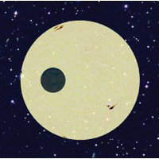

Figure 1: How much of the star’s
light do you think is blocked by this
transiting planet?

The area of the planet’s disk is only __________________ of the area of the star’s disk. (This is the same fraction as above). From this number, what is the relative size (e.g., diameter) of the planet, compared to its host star? (This is the square root of the above.) __________________________________________________

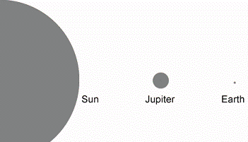
Figure 2: Earth’s diameter is about 0.01 times the Sun’s diameter. Jupiter is about 0.1 times the Sun’s diameter.

How does the size of your planet compare to Jupiter or Earth (see Figure 2)?

If you visited this planet, do you think you would weigh more or less than you do on Earth?

2. WHAT IS THE ORIENTATION OF YOUR PLANET’S ORBIT?
Does your planet transit across the middle of its star? Does the transit just graze the star (tilted orbit)? (Compare your class’ graph with the early predictions you made, using models.)

3. HOW CLOSE IS YOUR PLANET TO ITS STAR?
You’ll use a concept from physics and astronomy: The closer a planet is to its star, the faster it moves — and so the shorter the transit time. (For example, Venus transits our Sun in about 6 hours, while Mercury, which is closer to the Sun, takes only 4 hours.)

First, use your graph to estimate how long your planet takes to transit across the face of its star:
Duration of a transit, in hours: _________________________________

From this duration, do you think your planet is closer or farther from its star than Earth is from our Sun?
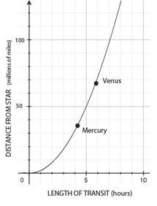
You can get a better estimate of how close your planet is to its star, by using the following graph. This graph shows the duration of a transit, for different distances from a Sun-like star.

Figure 3: GRAPH OF TRANSIT
DURATION vs DISTANCE FROM
PLANET TO ITS STAR.

Once you know how long your planet’s
transit takes, you can read off its
distance from its star. This graph is
only approximate, and applies to
stars similar to our Sun.

Is your planet closer to its star than Mercury is to the Sun? How hot do you think your planet must be?

4. Distance from Earth to your planet
Your star and its planet are just a dot in your telescope image. Obviously, they must be very far away. But how far is far? How long would it take you to travel to this alien place? And how long would it take any creatures that live there to reach Earth — or at least send a message?

BACKGROUND
You might think it’s impossible to tell anything about that dot. Fortunately, all light contains information about the object that it came from. In this investigation, you’ll use the brightness of the star’s light to help you estimate how far away the star is. You’ll use a simple concept: The farther away a light source, the dimmer the light it casts.

THE PLAN
You have already measured the brightness of your star. Now you’ll measure the brightness of a similar star: our own Sun. You’ll ask, “How many times dimmer is my star, compared to the Sun?”
Using this ratio, you’ll estimate, “How many times farther away is my star, compared to the Sun?” (You’ll use a simple rule that lets you compare distances if you have already compared brightnesses.)

Big Idea: “The farther away a light source, the dimmer the light it casts.”
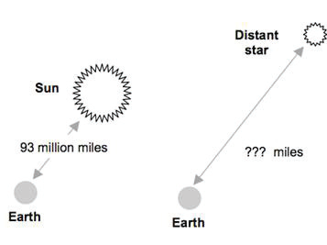

MEASURING OUR SUN’S BRIGHTNESS
You’ll use an image of the Sun that was also taken with the MicroObservatory telescope. Download it from our class website (sidebar – Telescope Image Download) and open it up in MicroObservatory. Use the circle tool and Measure (Process Menu) to get a brightness count for the Sun.

You will not need to subtract a “dark image” as you did with your star, nor will you need to measure the background sky brightness. The Sun is so bright that the other sources of error are insignificant by comparison.

IMPORTANT: Make sure the measurement window is wide enough to see the whole number. The Sun’s brightness will be eight or nine or more digits long! Use the Total measurement.
Record your Sun measurement in the right-hand column in Table 1.3
Record your star’s brightness in the left column of Table 1.3. (Use your “corrected target star brightness” measurement).

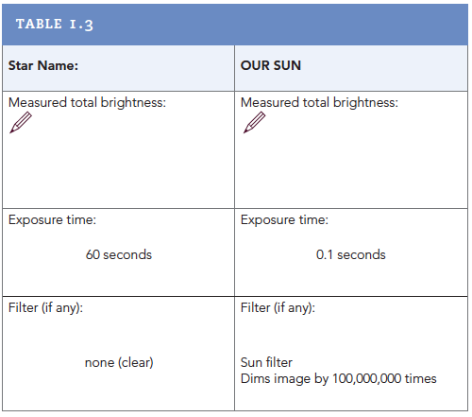

To determine the distance to your star, just follow the steps below. Keep a record of your measurements and calculations in the spaces provided.

COMPARING THE BRIGHTNESS OF THE SUN AND YOUR STAR
Simply comparing the brightnesses you measured for your star and the Sun wouldn’t be a fair comparison: As you can see from Table 1.3, the exposure times of the two images were different. Also, the Sun image was taken with a filter, but the star image was not.
• The star’s exposure time was 60 seconds and the Sun’s exposure time was 0.1 second.
• The Sun filter allows through only 1 part in 100 million of the Sun’s light (otherwise, the telescope mirror would melt!)

To make a fair comparison, you’ll have to adjust for these differences.

HOW WILL YOU MAKE A FAIR COMPARISON?
With your team or your class, discuss how you would answer the following question:
“If the exposure time for the Sun image had been 60 seconds instead of only 0.1 seconds, how many times more light would have reached the telescope’s sensor? How many times larger do you think your brightness measurement would be?”

For a 60-second exposure, I think the Sun’s measured brightness would be:__________________________ times greater than what I measured. Now discuss how you would answer the following question:
“If the Sun’s image had been taken without the Sun filter, how many times more light would have reached the telescope’s sensor? How many times larger do you think your brightness measurement would be?” (The telescope’s Sun filter lets through only 1 part in 100 million of the light falling on it.)

Without a filter, I think the Sun’s measured brightness would be ____________________________ times larger than what I measured. Compare the Sun with your star: How many times brighter than your star is the Sun?

Calculations:

The Sun appears _________________________times brighter than my star. (c)
Or to put it another way, how many times dimmer than the Sun is your star?
My star appears _________________________times dimmer than the Sun. (c)

CALCULATE YOUR STAR’S DISTANCE FROM EARTH
You might think that if a light appears a million times dimmer than its twin, it must be a million times farther away. But the rule is a little more complicated:

As a light gets farther away, it becomes dimmer in proportion to the square of the distance. For example, if the Sun were 1000 times farther away, it would appear 1,000,000 times dimmer. So you can square the relative distance to get the relative dimness. Or you can take the square root of the relative dimness (or brightness) to get the relative distance.
Discuss with your team: “Given your finding for the relative brightness of your star and Sun, what is their relative distance? That is, how much farther than the Sun is your star, in order to appear as dim as it does?”

As a source of light gets further from Earth, the light dims in a predictable way, according to the inverse square law. According to this law, a star that appears 100 times dimmer than its twin will be only 10 times farther away. Now, use the inverse-square law to calculate the star’s
distance from Earth:
• Compare your star’s distance from Earth with the Sun’s distance from Earth: How many times farther must your star be, in order to be as much dimmer as you just found? (This is the square root of (c) above).

Calculations:

My star is ________________________times farther than the Sun. (d) If the Sun is 93 million miles (150 million kilometers) from Earth, how far is your star?

Calculations:

The distance to my star is ________________________________miles.

CONVERT YOUR DISTANCE TO LIGHT-YEARS.
The universe is vast, and the distances between stars and between galaxies are huge. To reduce large numbers to a more manageable size, astronomers describe distances in terms of light-years. A light-year is the distance light would travel in a year, which is about 6 trillion miles!
(This is 6 x 1012 miles.)

How far is your star in light-years, if one light-year is 6 trillion miles?

Calculations:

The distance to my star in light-years is ______________________.
This means it would take ________________________ years for light to travel to Earth from the star.

Now that you’ve figured out the distance to your star, what does that number mean? Here are some questions to get you thinking. There’s space to jot down your thoughts below.

1. In the science fiction series, Star Trek, the starship Enterprise can travel at ten times the speed of light (“Warp 10”). Roughly how long would it take the fictional USS Enterprise to
get to your star, from Earth?

2. You’ve been asked by the President to communicate with any beings in your star system. You’ll use pulses of laser light and also radio waves (which are a form of light). How long will it take a message to get there? How long would the President be waiting for a reply?

3. What do you make of the fact that nature has isolated solar systems from each other by such vast distances?! Is this a bad thing, or a good thing — or both?

4. Compare your result to the published scientific value for the distance to your star. Remember, in science there are no answers, only results. How much confidence do you have in your findings?

5. Why do you think your result might differ from professional astronomers’ results? What are some of the possible sources of error in your measurements? Also consider whether the assumptions you
made might not be completely accurate.

Create a portrait of your planet
1. Based on your notes on the previous pages, write a paragraph describing what you learned about your planet size compared to Earth, and what you’ve concluded about its orbit. Support your conclusions with evidence from your light curve.

