2012-13 Barge Astronomy 1st Semester Final Review Questions
Use the chapters in the textbook The Cosmos: Astronomy in the New Millennium by Pasachoff & Filippenko as a resource, either 2nd or 3rd edition. Not everything in every chapter will be on the final.

Constellations (Chp 1; Chp 4 pg 63-67; A Walk Through the Sky (small textbook); Star Charts)
Why aren’t the same constellations visible at night all year long?
Why are there different constellations visible during different seasons?
How are stars’ brightness measured (magnitude)?
What does this have to do with the orbit of the earth around the sun?
From Chicago, how do stars appear to move across the sky?
Be able to identify on a star chart and describe where in the sky (northern sky or southern sky) you can find the following constellations and their brightest stars:
Fall
Summer Triangle – Cygnus (Deneb), Lyra (Vega), Aquila (Altair)
Cassiopeia, Ursa Major, Ursa Minor
Winter
Orion (Betelgeuse, Alnitak (east), Alnilam (center), Mintaka (west), Rigel), Canis Major (Sirius), Canis Minor (Procyon), Gemini (Pollux, Castor), Auriga (Capella), Taurus (Aldebaran), Cassiopeia, Ursa Major, Ursa Minor

Telescopes (Chp 3; Handouts from class)
Explain the basic differences between a refracting telescope and a reflecting telescope.
Can you explain the difference between the objective lens or mirror and the eyepiece in a telescope?
Can you explain the difference in the following terms
Focal length & aperture
Focal ratio & magnification
Could you trace light rays as they move through the following telescopes?
Reflecting, refracting, catadioptric (combination)
What is the difference between a Galilean telescope and a Newtonian telescope?
Can you explain resolution? Focus? Chromatic aberration?
Who was the first person to record the use of a telescope on the sky? What did he discover?
Who invented the refracting telescope? Why?
Can you calculate magnification if given a telescope’s and eye piece’s focal lengths?
Would you be able to pick adequate eye pieces to use with a particular telescope
Can you explain what MEM is and the 20x rule? Could you use it to pick out an appropriate eye piece?
Can you explain how a ccd camera takes a telescope picture and how that picture is unique – what information is embedded in the pixels?
Can you use an image processing program to manipulate a telescope ccd image? (Either ImageJ or MicroObservatory Image); Can you download an image, open it, adjust it, measure the light in it, measure size or distance in it, save it as a jpeg?

Light (Chp 2 pg 21-23; Chp 3; Chp 5; class notes)
Explain what light is. Can you use the following terms correctly to explain the electromagnetic spectrum?
Magnetic & electric fields; energy; frequency; wavelength; photon
Can you name the different types of electromagnetic energy in order from most to least energetic?
Can you explain why ionizing radiation (ultraviolet, x-ray, gamma) is dangerous?
Can you explain what a light year is?
Can you describe how the following people contributed to the knowledge of the electromagnetic spectrum?
a. Isaac Newton b. William Herschel c. Johann Ritter
d. Thomas Young e. Hans Christian Orsted f. Michael Faraday
g. James Clerk Maxwell h. Henrich Hertz i. Wilhelm Roentgen
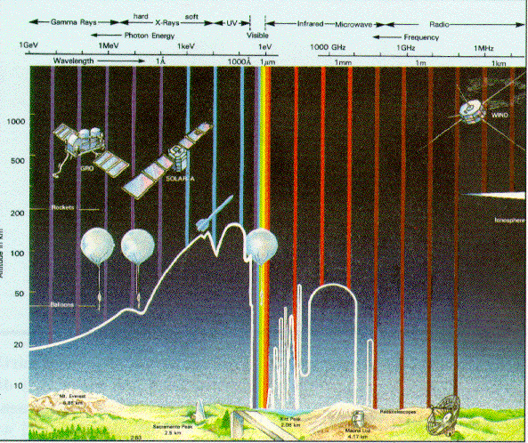
j. Ernest Rutherford & Paul Villard

Can you describe the atmospheric window? (What does this picture mean? )
Can you explain the following terms in terms of how light interacts with matter? Reflection; transmission; absorption; emission
Can you draw a picture that shows what those terms in the previous question mean?
Can you describe why an astronomer may want to take an image of an object with infrared light and also visible light? What would be the use of looking at something with both kinds of light?

Filters (Chp 3 pp 44-49; Class handouts/activities)
Can you explain how a filter interacts with light? Can you identify which part of the picture shows reflection, transmission, absorption, and transmission?
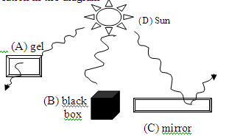
Can you describe why astronomers bother to build telescopes that see these different kinds of light? What would be the use of looking at something in different kinds of light?
Can you use an image processing program to measure how much light is coming from a particular star or object taken with specific filters and draw conclusions about the type of light the object emits?

Miscellaneous (Chp 4 pg 63-71)
Can you define the following terms?
  - Spring Equinox d. meridian g. orbit
  - Summer Solstice e. zenith h. revolution
  - Ecliptic f. horizon i. rotation
j. Winter Solstice k. Fall equinox

