Blackbody Curves
A blackbody radiation curve is the type of spectrum that one sees from hot and dense objects (think back to Kirchoff’s laws). Examples of blackbody curves are shown below for stars A, X, Y, Z. The two most important features of a star’s spectral curve (or blackbody curve) are:
- It’s maximum height or peak – where the energy output is greatest.
- The ‘maximum’ wavelength – the wavelength that corresponds to the maximum height.
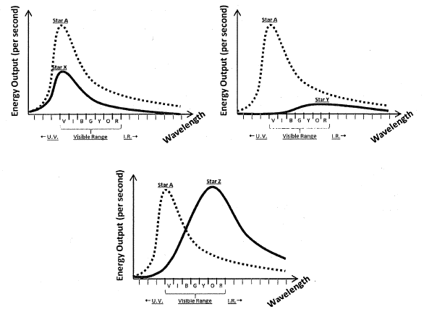
Above are three spectral curves showing stars A, X, Y, Z. Star A is shown in all of the plots as a point of comparison. Assume that stars A and Y are the same size.
7. Between stars A and Y, which star looks redder? Explain your reasoning.

8. Using all of the blackbody curves shown above, circle the charateristics shown in the table below that best correspond with Stars A and Star X.
Peaks at a longer wavelength: Star A Star B Same Neither
Looks Red: Star A Star B Both Neither
Looks Blue: Star A Star B Both Neither
Greater Energy Output Star A Star B Both Neither
9. Out of all the Stars (A, X, Y, Z), which one has the higher luminosity? Explain your reasoning.

Wien’s Law
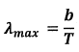
From blackbody curves, it is actually possible to determine the approximate surface temperature of a star, through the use of Wien’s Law:

Where λ max is the wavelength that corresponds to the maximum energy output; T is the surface temperature of the star; and B is a constant: b= 3 x 10⁶ k nm.

Use the following stellar spectral curves for questions 10 – 13.
Star A
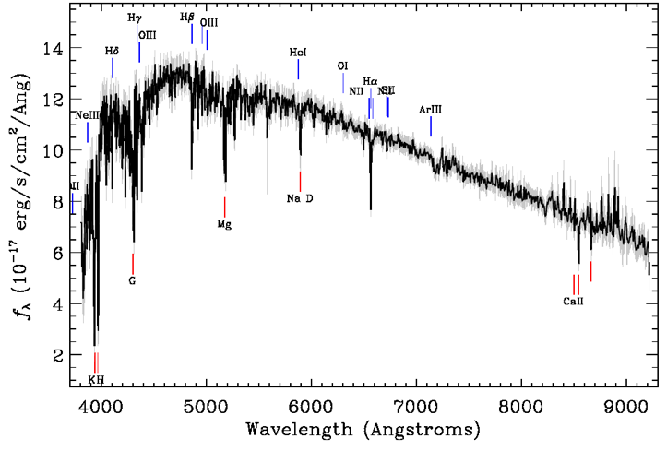
10. What is the surface temperature of Star A?

11. What color is Star A?

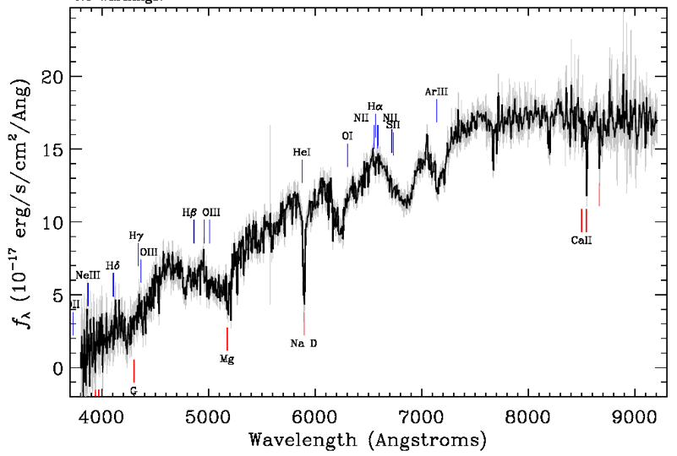
Star B
12. What is the surface temperature of Star B?

13. What color is Star B?

14. Star Omicron has a temperature of 3,000 K. What is its peak wavelength?

15. Star Sigma has a temperature of 6,000 K. What is its peak wavelength?

16. Based upon your answers to 14 and 15 (or by just looking at the equation), how does Wien’s law scale? (are T and λ max proportional, inversely proportional, etc.?)

17. The stars A, X, Y, Z shown in spectral curves on page 2 have the following peak wavelengths:
A: λ max = 300 nm
X: λ max = 300 nm
Y: λ max = 600 nm
Z: λ max = 600 nm
Without doing any math, which stars have the same temperature?

(Notice how temperature is not directly related to luminosity! Stars of different luminoisities can have the same temperature.)

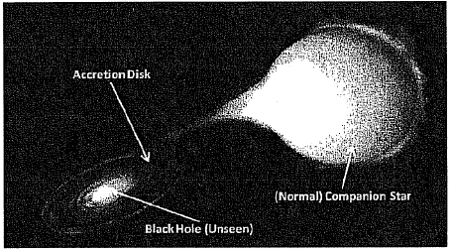
18. When black holes ‘sucks’ in gas, this gas can collide and pile up, while being heated up to extremely high temperatures (T ` 1,000,000 K). This pile up of gas forms what accretion disks – as illustrated in the figure at right. Using Wien’s law, what wavelength would an accretion disk emit most of its light in?

19. If you were an astronomer interested in observing accretion disks (like in the last problem), which of the following telescopes would you likely try to request time on? Explain your answer.
Telescope: Wavelength-band in which it observes:
Very Large Array Radio: > 10,000,000 nm
Planck (Space Telescope) Radio: 350,000 – 10,000,000 nm
Hubble Space Telescope Optical: 1,000 – 100 nm
Chandra X-Ray Observatory X-ray: 0.01 – 10 nm
Fermi Gamma-Ray Space Telescope γ-ray: < 0.01 nm

20. The cosmic microwave background is radiation that is actually leftover from the Big Bang. It currently has a temperature of 3 Kelvin. What is its peak wavelength? Which telescope (from question 19) would you use to observe it?

21. Proxima Centauri is a cool, red-dwarf star with a surface temperature ½ that of the Sun. If the Sun has a peak wavelength (λ max) of 500 nm, what is the peak wavelength of Proxima Centauri? Is Proxima Centauri redder or bluer than the Sun? Which telescope (from question 19) would you use to observe Proxima Centauri?

The H-R Diagram
The Hertzprung-Russell diagram is a scatter plot of stars as a function of their luminosity and temperature. They are one of the most useful tools used by astronomers in order to determine the properties of stars. Since the H-R Diagram plots temperatures and luminosities, you could almost think of it as a graph of Stefan-Boltzmann’s law (with stars of different radius).
L = 4πR²σT⁴ Luminosity is affected by the size of a star (4σR²) and the temperature (T⁴)
Use the following H-R Diagram to answer the following questions. Base your answers solely off the plot – do not use Stefan-Boltzmann’s law to solve for any direct values.
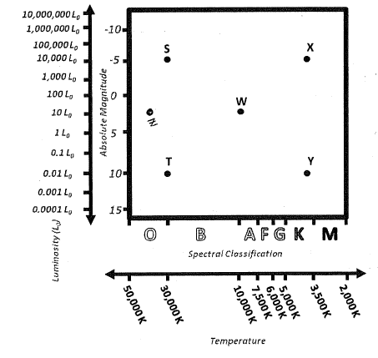
25. Stars S and T have the same surface temperature. Given that Star S is actually much more luminous than Star T, what can you conclude about the size of Star S compared to Star T? Explain your reasoning.

26. Star S has a greater surface temperature than Star X. Given that Star X is actually just as luminous as Star S, what can you conclude about the size of Star X compared to Star S? Explain your reasoning.

27. Based on the information presented in the H-R diagram, which star is larger: X or Y? Explain your reasoning.

28. Based on the information presented in the H-R diagram, which star is larger: Y or T? Explain your reasoning.

29. On the H-R Diagram, draw a “Star Z” at the position of a star smaller in size than Star W, but with the same luminosity. Explain your reasoning.

30. It is very difficult to accurately predict how the size of Star S will compare to that of Star W (without performing a calculation of some kind). Explain what makes a graphical comparison of these stars so difficult.

31. Thinking back to Wien’s law, between Star S and Y, which is redder? Explain your reasoning.

32. Thinking back to Wien’s law, between Star T and W, which star is bluer? Explain your reasoning.

33. What kind of star (what stages of the star life cycle) are at each position on the H-R diagram?
Position Type of Star
S
T
W
X
Y

