Name _________________________________________________ Redshift Practice

1. The following spectra is from a star at rest.
400 nm 500 nm 600 nm 700 nm
Identify which spectra is redshifted and which is blueshifted.

2. Match up the distances with the correct spectral curve. Remember the curve tells you how much of each type of light the object gives off and the absorption lines tell you what kind of elements the object is made of. A megaparsec is 3 x 10²² meters, a very big distance!

i.) 0 Megaparsecs ii.) 300 Megaparsecs iii) 1000 Megaparsecs
a. _______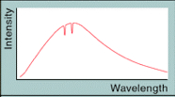 b. _______ 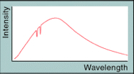 c.___________ 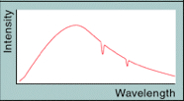

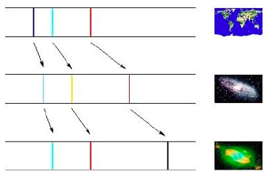
3. Explain what the following diagram is showing about light.

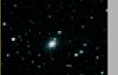

4. Following is a spectra from a laboratory reference.
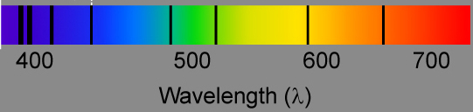

Identify each spectra below as one of the following.
i. a star ii. a nearby galaxy iii. A distant galaxy iv. A very distant galaxy

a. ___________________
b. ___________________
c. ___________________
d___________________

5. A star in our galaxy is observed to have all its spectral lines redshifted by a small fraction. What is the most obvious deduction you could make from this observation?

6. Quasars or QSOs show Lyman α lines in the visible part of their spectra obtained on Earth. a) What does this suggest about them? b) Why do we not observe Lyman α lines in the visible region of stellar spectra even though stars have abundant hydrogen present?

7. Visit the Runaway Universe Moving Target web page and do the Moving Target animation. Record your answers for Reading Reshifts http://www.pbs.org/wgbh/nova/universe/movi_flash.html

Moving Towards Us Stationary Moving Away from Us
Fast Slow Slow Fast

