SDSS Practice - Wien’s Law, Blackbodies, Spectra Practice

1. Use the Navigate tool to look up the object at RA=146.06230 and DEC=0.50312. We use RA and Dec in decimal form. Look at the spectra. Use its peak wavelength to determine its temperature.

2. Use the Navigate tool to look up object RA=200.20903 and Dec=-0.07525. Use its spectra to determine the temperature of star 2.

3. Find the picture of the star at RA=145.28414 and Dec=0.70630. This star is a spectral class K star. What can you say about its relative temperature based on its spectral class?

4. Use the Search tool to find object 1237648721251008546. What is this object? What color is this object? Which type of light does this object give off the most of?

5. Use the Search tool and look up object 1237648720693690521. What is this object? Look at the spectra. There is a significant line at about 7100 angstroms. What element is indicated by this line? Is the object emitting it or absorbing it?

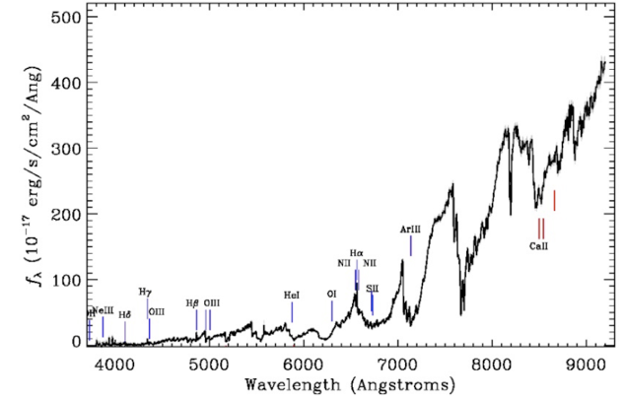6. Patterns in spectral curves have been found between the types of absorption or emission lines and the temperatures of the stars. Compare the three stellar spectral curves. Use the spectral line chart below to determine the spectral type of each star.

|  |  |  |
| --- | --- | --- |
| Spectral Type | Temperature  K | Spectral  Lines |
| O | 28,000 – 50,000 | Ionized helium |
| B | 10,000 – 28,000 | Helium, some hydrogen |
| A | 7500 – 10,000 | Strong hydrogen, some ionized metals |
| F | 6000 – 7500 | Hydrogen, ionized calcium (labeled as H and K) and iron |
| G | 5000 – 6000 | Neutral and ionized metals, especially calcium; strong G band |
| K | 3500 – 5000 | Neutral metals; sodium |
| M | 2500 – 3500 | Strong titanium oxide, very strong sodium |

Image A

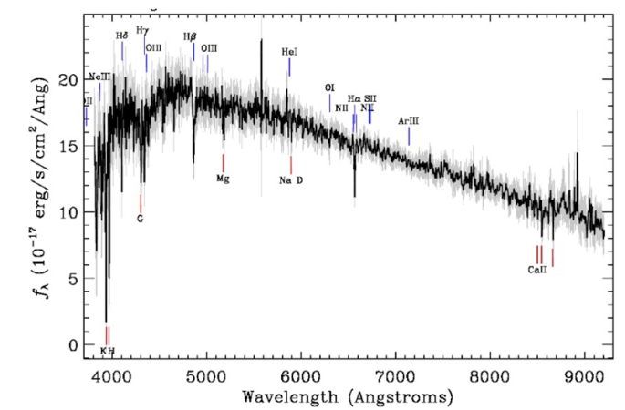

Image B

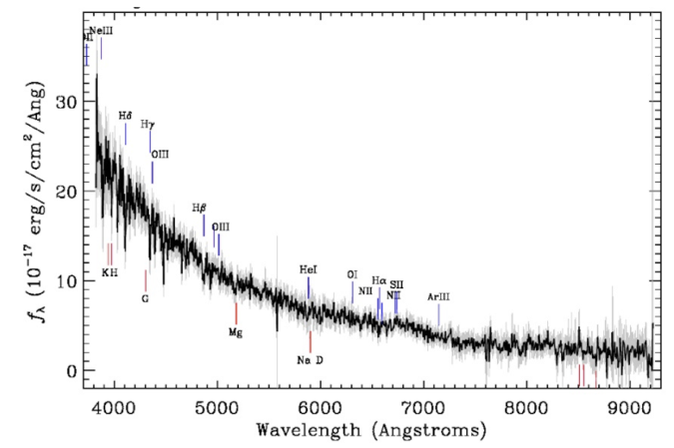

Image C

7. Use the Search tool to look up the picture of object 1237674649391595635. Which stellar spectra from question 6 belongs to this object?

8. Look at the image below of two blackbody curves from two different stars. Both stars are a class A spectral type. Which star is larger? Remember the x-axis is wavelength and the y-axis is flux or energy (you can also think of it as brightness) given off by the star. Explain your reasoning for your answer.

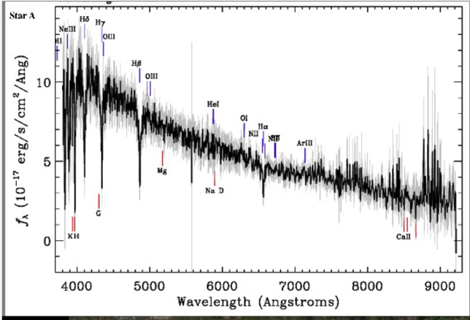 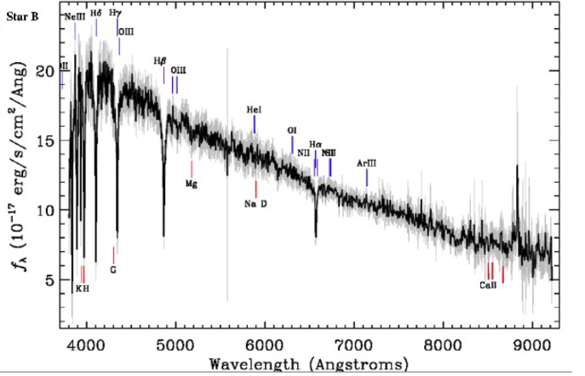

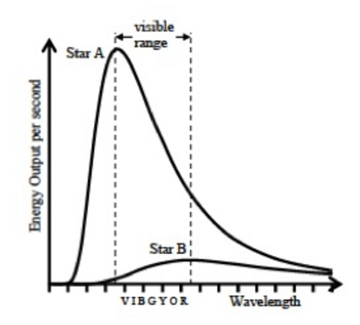

Use the image of the blackbody curve below to answer questions 9 and 10.

9. Which of the two stars (A or B) emits light with the shorter peak wavelength?

a. Star A

b. Star B

c. Both stars peak emissions are at the same wavelength

d. None of the above are possible

10. Determine which of the following best describes how Star B would appear as compared with Star A.

a. Star B would appear more blue than Star A

b. Both stars would appear more blue than red

c. Star B would appear more red than Star A

d. Both stars would appear more red than blue

e. None of the above.

Use the image below of four different blackbody curves to answer questions 11 and 12.

11. List the stars in order from the coolest to the hottest temperature. Explain your reasoning.

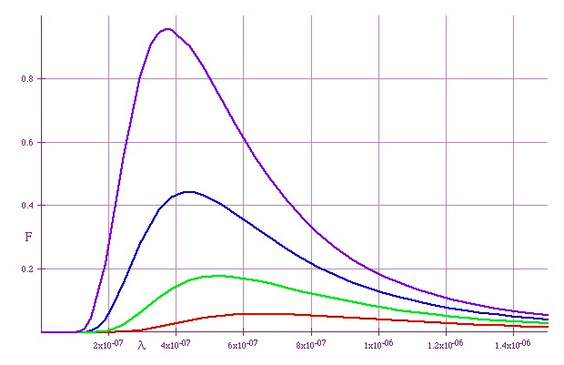

A

B

C

D

12. List the stars in order of dimmest to brightest.

13. When SDSS looks at an object, it classifies it based on its picture. This classification (star, qso or galaxy) is listed on the Navigate page for the object in box on the right with green letters. This first classification is also listed at the top of the object’s Explore page. When a spectrum is taken of the object, SDSS reclassifies the object if it shows it is something different than thought of at first. The classification based on spectra is listed under the Optical spectra information at the bottom of the Explore page as Class. This information is also found on the images of the spectrum.

Look up the following object using either the Navigate tool or the Search tool.

Object ID: 1237663530261807382 RA=130.656473859 Dec=57.571677486

a. What was the original classification of the object?

b. What was the object really found to be through spectra?

14. Look up object 1237648720693755925 using the Search tool or using the Navigate tool with RA= 179.700240257and Dec= -0.589650145.

a. What is this star’s peak wavelength?

b. What is this star’s temperature?

c. What is this star’s spectral type? Use chart from question 6.

d. Name one element found in this star.

e. Through which filter (ultraviolet, green, red, near infrared, or far infrared) is this star the brightest?

To read more of blackbody radiation, temperature, peak wavelength and color of stars, read the first several sections of chapter 11 in textbook Cosmos.

See Section titles below in chp 11. 2nd edition of The Cosmos, pages 217 - 227; Similar pages in 3rd edition. Sections "Colors and Temperatures" "The Spectral Types of Stars" "Luminosity" A Closer Look boxes "Using Absolute Magnitudes" "A Star's Luminosity"