Spectral Series of Hydrogen Name __________________________________________________________

To to the website http://www.bigs.de/en/shop/anim/termsch01.swf
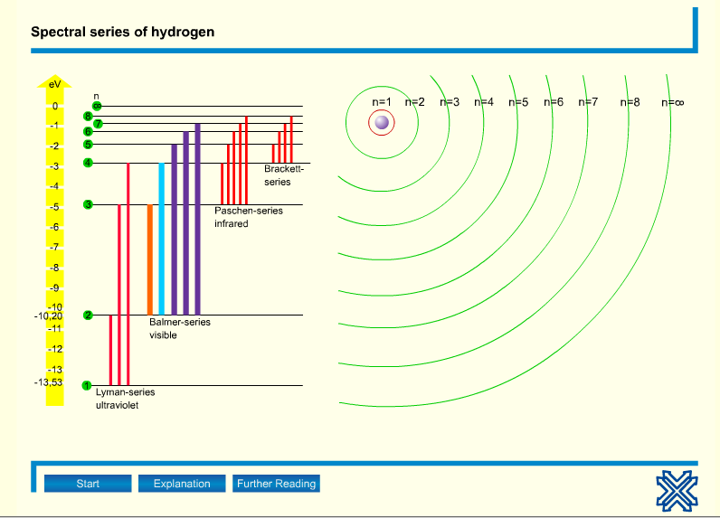
Use this animation to figure out the differences between the Lyman-series, the Balmer-series, the Paschen-series and the Brackett-series.
Explain what is happening for each series. Think about what is going on with energy and the electrons in the hydrogen atom.
When you click the Start button, you will be able to choose whether to look at only one of the series or all of them.

Lyman Series

Balmer Series

Use this animation to figure out the differences between the Lyman-series, the Balmer-series, the Paschen-series and the Brackett-series.
Explain what is happening for each series. Think about what is going on with energy and the electrons in the hydrogen atom.
When you click the Start button, you will be able to choose whether to look at only one of the series or all of them.

Paschen Series

Brackett Series

