Spectroscopy Questions
Name _____________________________________________________

- Sketch intensity plots for
  - i) a continuous spectrum
  - ii) an absorption spectrum
  - iii) an emission spectrum.
- Sketch Blackbody curves for a 12,000 and a 5,000 K black body on the same axes. Identify and account for two differences in the curves. In what ways are they similar?

- Identify an astronomical source for each of the following types of spectrum:
  - i) An emission spectrum
  - ii) an absorption spectrum
- Sketch the photographic spectrum (picture not graph) you would expect to see from
  - i) an incandescent lamp
  - ii) a hydrogen gas discharge tube
  - iii) reflected sunlight
  - iv) a fluorescent lamp

- Explain the spectral features you would expect to find in an emission nebula such as M 42, the Great Nebula of Orion.

- Why do we see spectral lines of ionised He⁺ in O-class stars but not in the Sun's spectrum?

- What does the presence of large number of molecular spectral lines (from molecules) in M-class stars suggest about their effective temperature?

- Describe two ways in which the spectrum of a star can be used to determine its effective temperature.

- If the core of a main sequence star acts like a black body source of a continuous spectrum, why do we typically see absorption lines in stellar spectra?

- Why do most modern astronomical spectrographs uses diffraction gratings rather than prisms to disperse light?

- Why does an O-class star appear blue and an M-class star appear red?

- If a star has a peak wavelength of 450 nm at maximum intensity calculate its effective temperature.

- Which of the four stars below, A, B, C or D is hottest? Justify your answer. (Ignore the blue background lines in each spectrum).
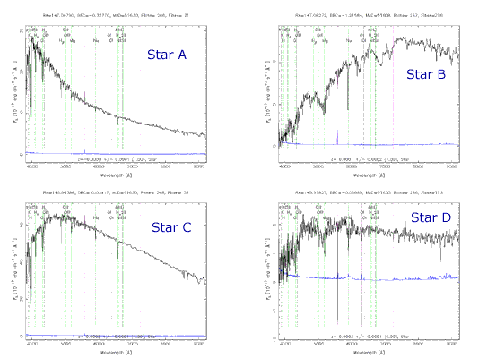
Credit: Spectra courtesy of The Sloan Digital Sky Survey
- In the diagram in question 19 above, which star is coolest? How can you tell?

- Construct a table showing the spectral classes, key spectral features, color and effective temperature range for stars.

