Photometry for ExoPlanets
Big Picture
1. Subtracting out excess light – We take out the background light from our images so we are only dealing with light from the exoplanet star. Light pixels that are simply from electronic “noise” associated with the telescope hardware will be subtracted from the image.
2. Measuring star brightness - You’ll measure the brightness of the target exoplanet star, two comparison stars and two dark areas of the sky to get the most accurate reading. Lots of things in nature can cause a star’s brightness to appear to dim (for example clouds drifting across the telescope view). These natural occurrences should have the same effect on all of the stars in our field of view. If we assume that the comparison stars don’t normally change in brightness due to transiting planets, we can compare the brightness of our exoplanet star to the comparison stars.

Star names and numbers in the tables below are sample measurements from example stars.

Step 1. – Subtracting out excess light
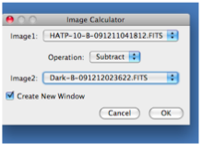
- Open the opaque filter image in MicroObservatory. It has the word Dark in its name. You should be able to find it in the list of images. If there is more than one, just use one that was taken close to when your images were taken.
- Open the FITS image of your exoplanet star in MicroObservatory Image. Under Process in the drop down menu select Image Calculator. Subtract the opaque image from the exoplanet star image and make sure the box Create New Window is checked. Then hit ok.
- A third untitled image will be created. This is the image you will use for your measurements.

Step 2. – Adjust the image
- Under the Process menu, select Adjust Image. In the small window that opens, select Auto.
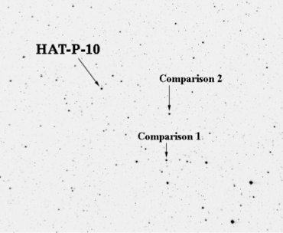
- Adjusting the image will make the stars in your image easier to see.

Step 3 – Finding your star
- Locate your exoplanet star and the two comparison stars (also called reference or companion stars) on this 3rd image using the Exo-planet Identification Star Chart.

Step 3 – Measuring the brightness of an exoplanet star
- Click on the magnifying glass icon at the top left of the image. Move the cursor so it is centered between your exoplanet star and the two reference stars noted on the star chart. Click several times to enlarge the image. Your exoplanet star and its two reference stars should remain in the field of view.
- Click on the circle icon at the top of the image. Move the cursor so it is near your exoplanet star and drag it to make a circle that is 4.5in in radius. This radius should be used for all measurements!
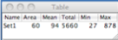
- Adjust the location of the circle so it completely encircles the pixels of light associated with your star. You can move the circle by dragging it or by using the i, j, k, and l keys (i=up, j=left, k=down, l=right).
- Hold down the “command/apple” m” on Macs and “control” “m” on PCs. A table is created at the top of the image with the brightness measurement.

Step 4 – Measuring the brightness of comparison stars
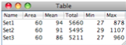
- Drag the circle to the first companion star, moving in a clockwise direction. Position the circle and take another image.
- Repeat for the second comparison star. The results for both will appear in the Table as Set 2 and Set 3.

Step 5 – Measuring the brightness of background sky
- Repeat step 4 for two background locations. Select locations that are not on top of any stars. So in other words, select a dark piece of the sky or a part of the sky with no stars.
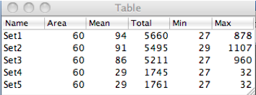
- Why am I doing this? The sky between the stars is not completely black. When you measure a star’s brightness, you’re actually measuring the brightness of the star plus the background sky. These background sky measurements will be subtracted.
- All of the images taken in step 4 and 5 will be added to your table as Set 4 and Set 5.
- What does all of the information in the table mean?
Area = the total number of pixels in your circle
Mean= the average value for each of the pixels in your circle
Total= the total brightness of the star (or background)
Min= the lowest brightness count in your circle of pixels
Max= the highest brightness count in your circle of pixels

Step 6 - Calculating the actual brightness of an exoplanet star – Use an Excel spreadsheet
- Copy all five rows from your chart. Paste them into an Excel spreadsheet. The titles of each column won’t copy so leave room for them and then type them in as column headings.
- Set up your spreadsheet to do the following calculations. Check with Ms. Barge if you aren’t sure how to do this. The numbers below are from the sample tables in the instructions above. REMEMBER to include the full name of your exoplanet image in your spreadsheet.
1. Find the average background sky (column G). First, find the average brightness of the background sky (add the two background measurements and divide by two.
(1761 + 1745)/2 = 1753
2. Find the corrected brightness for each star (column H, I, J). Subtract this average background measurement from each of the three brightness measurements (your exoplanet star and the two comparison stars)
5660 – 1753 = 3907 5495 – 1753 = 3742 5211 – 1753 = 3458
3. Calculate the average corrected brightness of the two comparison stars (column K). Add the two corrected brightness and divide by 2.
(3742 + 3458)/2 = 3600
4. Compare the exoplanet star with the comparisons using a ratio (column L). Compare the brightness of your exoplanet star with the average of the comparison stars by taking the ratio of the corrected star brightness to the average corrected comparison star brightness

