Light & Telescopes
_______________________________Lens – We don’t use these in telescopes because
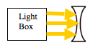
Llight Box

_________________________________Lens - We use these in telescopes because
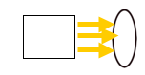

____________________________________Mirror - We don’t use these in telescopes because

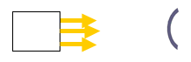

_____________________________________ Mirror - We use these in telescope because

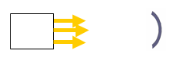

 | Lower Ratio | Higher ratio
Type of f ratio
(Fast / Slow)
Brightness
(brighter/dimmer)
Magnification
(higher/lower)
Field of View – FOV
(large, small)
Good for viewing (nebulae, star clusters, planets)

