Name: ________________________________________ Mitosis Internet Lesson
In this Internet lesson, you will review the steps of mitosis and view video simulations of cell division. You will also view an onion root tip and calculate the percentage of cells at each of the stages of cell division.
Mitosis Tutorial
http://www.cellsalive.com
On the left side of the screen is a navigation bar. Click on the link “Mitosis.” Read the text on this page and view the animation. You can slow down the video by clicking step by step through the phases.
- Which stage does the following occur?
  - Chromatin condenses into chromosomes ________________________________________________
  - Chromosomes align in center of cell ______________________________________________________
  - Longest part of the cell cycle ______________________________________________________________
  - Nuclear envelope breaks down ___________________________________________________________
  - Cell is cleaved into two new daughter cells ______________________________________________
  - Daughter chromosomes arrive at the poles ______________________________________________

Watch the video closely
- The colored chromosomes represent chromatids. There are two of each color because one is an exact duplicate of the other.
  - How many chromosomes are visible at the beginning of mitosis? ______________________
  - How many are in each daughter cell at the end of mitosis? ______________________________
  - The little green T shaped things on the cell are: __________________________________________
  - What happens to the centrioles during mitosis? __________________________________________

- Identify the stages of these cells:
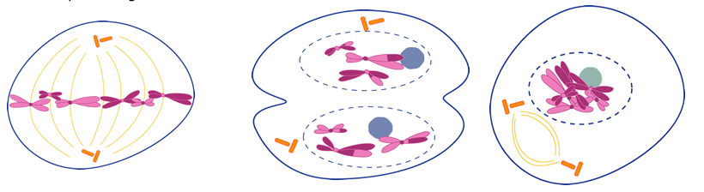
Another Mitosis Animation
Go to www.johnkyrk.com/mitosis.html
View the animation and sketch the cell in the phases listed on the next page.

Prophase | Metaphase | Telophase

Onion Root Tip – Online Activity
http://www.biology.arizona.edu/cell_bio/activities/cell_cycle/cell_cycle.html
Read the introduction, then click the “next” button.
You will have 36 cells to classify. Record your data in the chart below.
 | Interphase | Prophase | Metaphase | Anaphase | Telophase | Total
Number of cells |  |  |  |  |  | 36
Percent of cells
(calculate: number of cells divided by total cells x 100)

Did you forget a calcuator? No problem. Go to www.calculator.com and click on the “fractions” calculator. A window with a virtual calculator will open and you can do the math from there.
Mitosis in Whitefish & Onion Roots
Whitefish http://www.biologycorner.com/projects/mitosis/whitefish_embryo.html
Onion http://www.biologycorner.com/projects/mitosis/onion_root.html
For each organism, identify the stage of mitosis.
 | View 1 | View 2 | View 3 | View 4 | View 5
Whitefish |  |  |  |  | ****************
Onion

