Hatching Chicks

The Reproductive System and Fertilization

The rooster
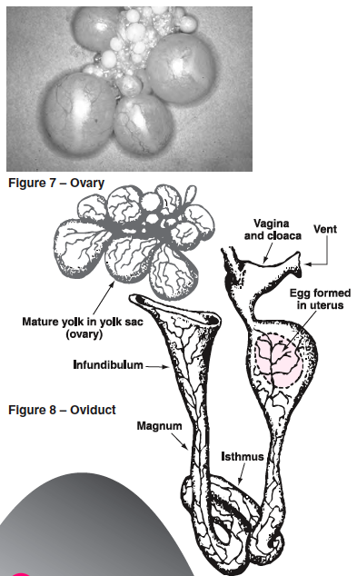
The male fowl has two testes along its back. These never descend into an external scrotum, as do those of other farm animals. A testis consists of a large number of very slender, convoluted ducts. The linings of these ducts give off sperm. The ducts eventually lead to the ductus deferens, a tube that conducts the sperm to a small papilla. Together, the two papilla serve as an intermittent organ. They are on the rear wall of the cloaca.
The rooster responds to light in the same way as the hen. Increasing day length causes the pituitary to release hormones. These, in turn, cause enlargement of the testes, androgen secretion and semen production, which stimulates mating behavior.

The hen
The reproductive system of the female chicken is in two parts: the ovary and oviduct. Unlike most female animals, which have two functioning ovaries, the chicken usually has only one. The right ovary stops developing when the female chick hatches, but the left one continues to mature.
The ovary is a cluster of sacs attached to the hen’s back about midway between the neck and the tail. It is fully formed when the chick hatches and contains several thousand tiny ova—each ovum within its own follicle. As the female reaches maturity, these ova develop a few at a time into yolks. (Figure 7)
The oviduct is a tube-like organ lying along the backbone between the ovary and the tail. In a mature hen, it is about 25 to 27 inches long. The yolk is completely formed in the ovary. When a yolk is fully developed, its follicle ruptures at the stigma line, releasing it from the ovary. It then enters the infundibulum, the entrance of the oviduct (Figure 8).

The other parts of the egg are added to the yolk as it passes through the oviduct. The chalazae, albumen, shell membranes and shell then form around the yolk to make the complete egg, which is then laid. This complete cycle usually takes from 23 to 32 hours. About 20 minutes after the egg is laid, another yolk is released and the process repeats itself.

Development takes place as follows:
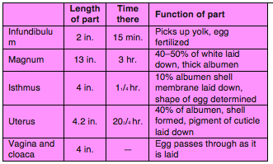

How eggs are fertilized
Each gender, the rooster and the hen, contributes something to the egg. The rooster provides sperm; the hen provides an ovum. When a rooster mates with a hen, it deposits sperm in the end of the oviduct. These sperm, containing male germ cells, travel the length of the oviduct and are stored in the infundibulum. On the surface of every egg yolk there can be seen a tiny, whitish spot called the blastodisc. This contains a single female cell. If sperm is present when a yolk enters the infundibulum, a single sperm penetrates the blastodisc, fertilizing it and causing it to become a blastoderm. Technically, the blastoderm is the true egg. Shortly after fertilization, the blastoderm begins to divide into two, four, eight and more cells. The first stages of embryonic development have begun and continue until the egg is laid. Development then subsides until the egg is incubated. The joining of sperm and ovum is called
fertilization. After fertilization, the egg can develop and become a chick.

The rooster must be present for an egg to be fertilized. Supermarket eggs are from hens that are raised without a rooster. Roosters are not necessary at farms where eggs are produced for people to consume. Eggs for incubation are grown at special farms called breeder farms where roosters are with the hens.

Development during incubation
As soon as the egg is heated and begins incubation, the cluster of cells in the blastoderm begins to multiply by successive divisions. The first cells formed are alike. Then, as the division of cells progresses, some differences begin to appear.

These differences become more and more pronounced. Gradually the various cells acquire specific characteristics of structure and cell grouping or layer. These cell groupings are called the ectoderm, mesoderm and endoderm. These three layers of cells constitute the materials out of which the various organs and systems of the body develop.

From the ectoderm, the skin, feathers, beak, claws, nervous system, lens and retina of the eye, linings of the mouth and vent develop. The mesoderm develops into the bone, muscle, blood, reproductive and excretory organs. The endoderm produces the linings of the digestive tract and the secretory and respiratory organs.

Development from a single cell to a pipping chick is a continuous, orderly process. It involves many changes from apparently simple to new, complex structures. From the structures arise all the organs and tissues of the living chick.

Physiological processes within the egg
Many physiological processes take place during the transformation of the embryo from egg to chick.
These processes are respiration, excretion, nutrition and protection.

For the embryo to develop without being connected to the hen’s body, nature has provided membranes outside the embryo’s body to enable the embryo to use all parts of the egg for growth and development. These “extra-embryonic” membranes are the yolk sac, amnion, chorion and allantois.

The yolk sac is a layer of tissue growing over the surface of the yolk. Its walls are lined with a special tissue that digests and absorbs the yolk material to provide food for the embryo. As embryonic development continues, the yolk sac is engulfed within the embryo and completely reabsorbed at hatching. At this time, enough nutritive material remains to feed the chick for up to three days.

The amnion is a transparent sac filled with colorless fluid that serves as a protective cushion during embryonic development. This amniotic fluid also permits the developing embryo to exercise. Specialized muscles developed in the amnion gently agitate the amniotic fluid. The movement keeps the growing parts free from one another, preventing adhesions and malformations.
The chorion contains the amnion and yolk sac. Initially, the chorion has no apparent function, but later the allantois fuses with it to form the choric-allantoic membrane. This enables the capillaries of the allantois to touch the shell membrane, allowing calcium reabsorption from the shell.

The allantois membrane has many functions. It:
• serves as an embryonic respiratory organ
• receives the excretions of the embryonic kidneys
• absorbs albumen, which serves as nutriment (protein) for the embryo
• absorbs calcium from the shell for the structural needs of the embryo.

The allantois differs from the amnion and chorion in that it arises within the body of the embryo. In fact, its closest portion remains within the embryo throughout the development.

