Finches in a Drought Name _____________________________ Period ______________

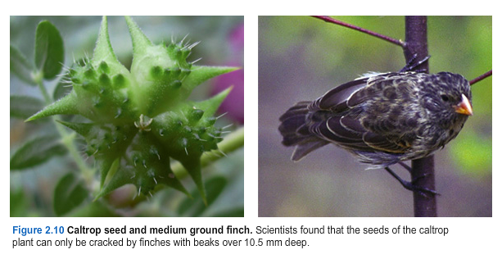

The Galapagos Islands are dry places, receiving on average 25cm (10 in) of rainfall a year. But in 1977, the Galapagos Island of Daphne Major received nearly zero rainfall – only 24mm, less than 1in. Using tweezers and nets, scientists on the island recorded how the number of seeds, insects and cati on the island of declined sharply, as organisms struggled to grow and survive without enough water. Small, soft seeds were favored by several species of finches on the island. These were eaten first, leaving only the hardest, most difficult-to-open seeds (figure 2.10)p.

The medium ground finch was hard hit by the changes in its food supply. Its beak is not large enough to crack a whole caltrop seedpod. Instead, it has to go through a labor-intensive process of holding the seedpod to the ground while peeling back layers of woody material, finally revealing a few seeds nestled inside. In 1977, many medium ground finches did not have beaks large enough to accomplish this. All over the island, medium ground finches began to die. The struggle to survive was so severe that none of the medium ground finches mated in 1977.

The drought ended in the spring of 1978. Only 20 percent of the original population of medium ground finches remained. Scientists measured the beak depth of all of the finches on the island, before and after the drought (figure 2.11). As a group, those that had survived were different from those that had perished (figure 2.12).

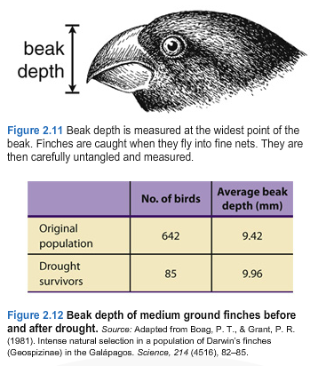
Did individual finches change due to the drought? Scientists measured each finch before and after the drought. These finches did lose a lot of weight. But their beaks, made of a hard material like your fingernails, were each the same size before and after the drought.

The scientists knew from past studies that beak size is a heritable trait. Heritable traits are passed from generation to the next. In other words, they are inherited. Because beak size is heritable, the scientists predicted that the offspring of the surviving finches would have beaks that resembled their parents’ beaks.

In the spring of 1978, the surviving medium ground finches reproduced. There weren’t many left, and there were many more males than females amongst the survivors. But the males sang their courtship songs, and the females chose their mates. The pairs made nests in the bushes and cactus plants, just as finches have bee doing for millions of years.

- What do you think the offspring looked like? In particular, how deep do you think the offspring’s beaks were?

To answer this question, study figure 2.13, which shows the beak depth of medium ground finch offspring born in 1976, before the drought, and in 1978, after the drought. Explain your reasoning.

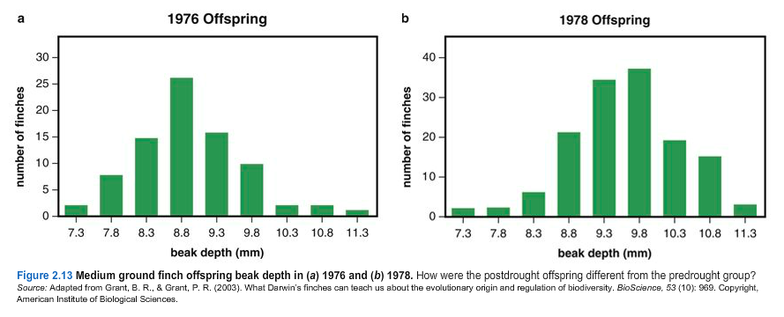

- Read more about the scientists who study these birds in the essay “Finch Scientists of the Galapagos.” [Paper book pg 105-106 online textbook page 301-305]. What was the most interesting thing you read about?

- Go to https://www.hhmi.org/biointeractive/origin-species-beak-finch and watch a video about the Grants who studied the finches and collected the data we used. Information about later events on the island is given. After watching, answer the following question: How do new species form? The film is 15 minutes.

