Energy Flow in the Hubbard Brook Forest
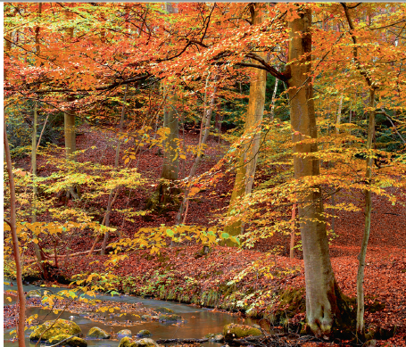

The Hubbard Brook Experimental Forest in the White Mountain National Forest in New Hampshire, has been the subject of ecological studies since the 1950s. This hardwood forest has been designated as a Long Term Ecological Research (LTER) site. In 1978, a researcher named James Gosz and many fellow scientists attempted to quantify energy flow throughout the site’s different trophic levels. The data that they collected follow below. Note that all the data are in kilocalories per square meter per year (kcal/m²/yr).

Measurement | Energy available to different trophic levels (kcal/m²/yr)
Solar energy available | 480,000
Solar energy reflected | 72,000
Solar energy converted to heat | 136,800
Solar energy used to drive evaporation of water from surfaces or through plants | 201,600
Solar energy converted by plants into chemical energy | 9,600
Energy in the form of producer biomass available to primary consumers | 4,800
Amount eaten by primary consumers | 3,500
Energy in the form of primary consumers biomass available to secondary consumers | 200

Generate a diagram that summarizes, in a way that makes sense to you, the data about the flow of energy in the Hubbard Brook ecosystem. Your final diagram should include:

a. Producers, primary consumers, and secondary consumers that are clearly labeled

b. Boxes or levels that are scaled to represent relative amounts of energy

c. Data about the energy that is available at each level

d. An indication of what supplies the system with energy ad where “lost” or inaccessible energy goes

