Cloning

Cloning is defined in different ways by various groups and organizations. A commonly used definition is that cloning is the production of genetically identical organisms. Identical twins fit that definition. Yet, accepting identical twins as clones would yield a variety of negative and positive responses. A more widely accepted definition comes from the American Medical Association (AMA): “Cloning is the production of genetically identical organisms via somatic cell nuclear transfer.”

Somatic cell nuclear transfer refers to the process of removing the nucleus of an ovum and replacing it with the nucleus of a somatic cell. In that way, the ovum gains a full set of genetic information from the existing organism, without fertilization. The genetic information transferred into the ovum may have no relation to the ovum. The last four words of the AMA’s definition gives a much more complete picture of what cloning means to most people today.
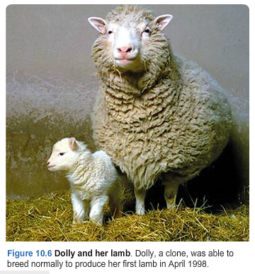
One of the world’s most famous clones was a sheep named Dolly (figure 10.6). We will use Dolly to illustrate the last four words of the AMA’s definition. A cell was removed from the udder of a six-year-old white-faced ewe (a somatic cell). An egg cell was removed from a black-faced sheep, and its nucleus was removed. The somatic cell was fused with the egg cell, from which the nucleus had been removed (nuclear transfer). Thus, the ovum gains a whole set of genetic information from the existing organism, without fertilization. At this point, the egg cell contained its original cytoplasm, including mitochondria and DNA. But it had the nucleus of another sheep. An electric shock was used to stimulate the egg cell to divide and develop. The egg cell developed normally to an early embryonic stage. It was then transplanted into a surrogate, black-faced ewe. On July 5, 1996, 148 days later, Dolly was born. Dolly appeared to have all the traits of the white-faced ewe whose somatic cell had been used in the cloning procedure.

Since Dolly, there have been clones of mice, cattle, and pigs. Does this mean that in the near future there will be human clones? Few doubt that the biological processes of human cloning could be successful with further research. However, the ethical implications – the “rights” and “wrongs” – of human cloning must be explored. We must develop an acceptable, comprehensive, and intelligent plan before human cloning has a chance to become a reality.

Dr. Arthur Caplan, is the director of the Center for Bioethics and professor of bioethics at the University of Pennsylvania. He was asked to describe the ethical pros and cons of cloning. He stated, “The pros are that you might be able to help infertile individuals and couples have children, and by making cloned cells, you might find a way to make tissues and organs to treat disease. That’s called therapeutic cloning. The cons are that human cloning is not safe. Animal cloning has produced many dead, deformed and diseased animals. However, I do favor making cloned cells for research” (2001). Some data that support Dr. Caplan’s objection come from experiences in cloning Dolly. It took scientists 277 tries before Dolly was created. In 277 nuclear fusions, only 29 embryos developed. Only 13 embryos appeared normal enough to implant in 13 ewes. Only Dolly’s surrogate mother gave birth. Experts say that the technique that produced Dolly fails 97% of the time. In addition, Dolly developed arthritis at age 5 ½, raising other concerns.

In 2003, scientists decided to euthanize Dolly because she had a serious lung infection. Dolly was relatively young when she got arthritis and the lung disease. Scientists, however, do not know whether the early onset of disease was a result of the cloning process. AS of this writing, a high percentage of scientists and bioethicists seem to oppose human cloning. However, cloning tissues and organs falls under a different category than cloning humans. The majority think that type of cloning would be beneficial to science.

Choose a topic to research. Find out what is going on in current research of this topic. What are the questions scientists are looking into? What concerns do ethicists have? What milestones have been reached? What does the future of this area look like?

Some possible topics:

Stem cells In-vitro fertilization (IVF) Surrogacy
GMO (Genetically Modified Foods) Transgenic Technology Pharmacogenomics
Conservation Genetics Human-Animal Chimeras Gene Therapy
CRISPR Gene Editing Technique 3-parent IVF Cloning
Human Genome Project (HGP) Celera Genomics Corporation Designer Babies
The Genetic Information Nondiscrimination Act DNA App Store Eugenics
The Nagoya Protocol on Access to Genetic Resources 23andMe (DNA sharing via iPhone)

