Madrid Program Syllabus
Science, July 4 – 15, 2016

Welcome! The goal of this program is to develop your ability to teach science in the English Language. In order to reach this goal we will work together to plan and teach engaging new lessons using the four universal facets of the teaching cycle: planning, instruction, assessment, reflection, as shown in Figure 2

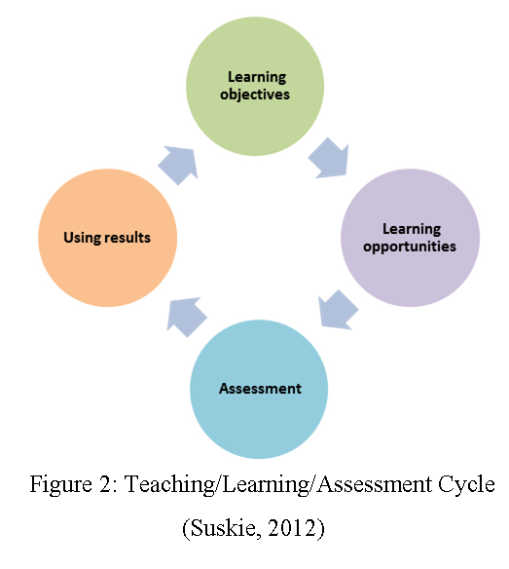
As we work together to grow our professional practice we will delve into specific aspects of the instruction phase that are proven to increase student engagement:
- Inquiry/hands-on activities,
- Discussion and questioning techniques
- Connecting theory to practice
- Effective use of technology in instruction.

Put succinctly the goals of this program are:

- Improve your ability to teach science in the English language.
- Improve your ability to teach using student-centered constructivist pedagogy.

We will participate in lessons that model this approach. We will then dissect these lessons to identify the structures for inquiry and questioning. Each teacher in the program will have the opportunity to plan, teach and reflect on lessons to take back to your classroom to increase your comfort with the English language and this student-centered constructivist approach.

Calendar
The calendar below shows the basic schedule of the class. The sequence may be modified as needed. Resources can be found at http://40two.info/barge/SMR/Science%20Methods%20Resources.html

 | Monday | Tuesday | Wednesday | Thursday | Friday
Week One  9-11 | July 4:  Orientation  Biology - Scaling /  Technology | July 5:  Earth Science-  Plate Tectonics II | July 6:  Astronomy - Star Chart / Star Cards | July 7:  Biology –  Whales Evolution | July 8:  Multiwavelength  Astronomy / Spectra /  SDSS
11:30-1:30 | Earth Science - Plate Tectonics I | Biology – BLAST: Protein to Disease | Lesson Work Time | Lesson Work Time | Lesson Work Time
Week Two  9-11 | July 11:  Biology – Evolution Sonoran Mice | July 12:  Mini Lessons Small Group Practice / Lesson Work Time | July 13:  Resource Sharing | July 14:  Lesson Presentations  5 @ 20 Minutes | July 15:  Lesson Presentations  5 @ 20 Minutes
11:30-1:30 | Mini Lessons Small Group Practice / Lesson Work Time | Mini Lessons Small Group Practice / Lesson Work Time | Lesson Presentations  5 @ 20 Minutes | Lesson Presentations  5 @ 20 Minutes | Wrap-up / Final Celebration

Throughout the two weeks of the program you will pick specific content ideas pertinent to you, and your classroom, and build up student-centered lessons, incorporating new language and engaging teaching methods.

Final Assignment
Working individually, you will design a lesson that you can teach in your classroom next year. The lesson will utilize the lesson plan format supplied to you by Roosevelt University, as a way of standardizing the planning and feedback for this program. You will have the opportunity to practice 5 minute portions of this lesson with small groups and then during the last days of the program, each member of the team will teach a 20-minute section of their lesson to the staff and fellow Madrid teachers.

Lesson Plan Format
There are many excellent lesson/unit-planning formats, one of which is presented in this program, Understanding By Design. This is the format selected to use in this class and you will use for your assignment. The template for the lesson is presented below:

Unit/Lesson:

Stage 1 – Desired Results
Established Goals: What is the goal of this lesson?

Understandings: Because of this lesson, students will understand that … | Essential Questions: What is the Big Idea or question this lesson is part of exploring?
Understandings: Because of this lesson, students will know … | Understandings: Because of this lesson, students will be able to …
Stage 2 – Assessment Evidence
Performance Tasks: What performance tasks or other evidence of learning is associated with this lesson?

Stage 3 – Learning Plan
H hook I introduction C content P practice R revise E evaluate
Learning Activities: What type of lesson (learning activity) is this one?

Your lesson/unit plan should include components from the following:
- Students constructing understanding from observations, data analysis, model fitting, etc
- Students explain, describe, discuss their thinking/explanations/understandings/etc
- Students create, using the knowledge they’ve constructed – answer to problem, a model, a design, a new object, etc.
- Student use technology – labpro, internet searches, prezi, Powerpoint, Excel, webpages, videos,
- apps, image processing, online databases, padlet, googledocs, etc

http://www.schreyerinstitute.psu.edu
Understanding By Design Framework http://www.ascd.org/research-a-topic/understanding-by-design-resources.aspx

