Cat Dissection
- Any “horseplay” during the dissection will result in an immediate dismissal of the cat project. You will not be allowed to participate in the cat dissection from then on and will be referred to administration for discipline.
- You are welcome to check out other groups cats, however please do not wonder around as people are cutting.
- In general, leave the specimen intact as much as possible. All parts of the cat should be kept in your bag. DO NOT THROW AWAY PARTS OF THE CAT IN THE NORMAL TRASH CAN. Leave it in your bag and all cat parts will be thrown away together (in an ethical manner).

Why dissect a cat? Charts cannot give a complete idea of what an organ or organ system is like. The concentration and involvement in searching out structures aids learning and develops skills that may be of later use. A cat is large enough for its internal organs (which are much like our own) to be found easily and for its blood vessels to be traced, but not so large as to present special difficulty in storage and handling.
While dissecting, observe these safety precautions. Wear safety glasses or regular glasses to protect the eyes if you have allergies or sensitive eyes. Contact lenses are not encouraged to be worn on dissection days. Gloves will be provided to you to protect your hands. You must wear the gloves, safety glasses and aprons.
Anatomical Terminology - Basic terminology reminder
Anterior (cranial) – towards the head
Posterior (caudal) – toward the tail
Dorsal (superior) – toward the backbone
Ventral (inferior) – toward the belly
Lateral - toward the side
Medial – toward the midline
Proximal – lying near the point of reference
Distal – lying further from the point of reference

Transverse (cross section) – perpendicular to the long axis of the body
Sagittal – a longitudinal section separating the body into right and left sides
Frontal (coronal) – a longitudinal section dividing the specimen into dorsal and ventral parts

Work through the dissection one part at a time. Between each dissection session, wrap the cat in wet paper towels and put it back into its bag. Clip the bag closed and put it in the refrigerator. Make sure your bag has your names on it.

Part I – Beginning the Dissection
Generally your specimen will be preserved with its limbs extended.

Spend a few minutes examining the external anatomy of your cat. Like most mammals, the cat is almost completely covered with a dense coat of hair. The primary function of mammalian hair is insulation, but there are interesting secondary functions as well. The cat has around its mouth, cheeks, and eyes, long hairs called vibrissae. These have a sensory function, allowing the cat to “feel” its way in darkness.
Other important sense organs located on or opening onto the head include the eyes, ears, and nose. The external nares (nostrils) are separated by a groove, the philtrum, which forms a cleft in the upper lip. In man the philtrum is normally closed and flat. The eyes face forward, giving the cat stereoscopic vision. Spread apart the upper and lower eyelids and locate, in the medial corner of the eye, the third eyelid or nictitating membrane. In life this is a transparent layer that helps protect and cleanse the eye. Mammanls are the only animals that have pinnae, external ear structures. These pinnae protect the ear openings and reflect sound into the middle ear.
Mammalian digits (toes) are usually tipped with claws, hooves, or nails. Carnivores have claws, and the cat’s claws are highly specialized so that they can be retracted. This protects them from being dulled by contact with the ground, yet they can be brought into play when needed. Notice that one claw on each foot is raised above the level of the rest. On the undersurface of each foot are epidermal thickenings called friction pads or tori. These cushion the step and give traction. There are seven tori on each forefoot and five on each hindfoot.
Mammals are animals with mammary glands. Cats have two rows of about five mammary glands each. Look for the nipples to the left and right of the ventral midline.
The cat’s tail is well developed and often expresses the cat’s mood. The anus, the posterior opening of the digestive system, is located just ventral to the base of the tail.
The external genitalia are the external sexual structures. Examine specimens of both sexes for these. The urogenital aperture, the opening of the female urogenital tract, is just central to the anus. At a similar location on the male is the scrotum, a sac containing testes. Immediately anterior to the scrotum is the prepuce, a slight swelling into which the penis is normally retracted.

1. With gloves on, remove the cat from its bag and lay the cat on a dissecting tray.
2. Place your cat ventral surface up on the dissecting tray, as seen in the picture packet.

Identify the gender of the cat. Males have a scrotum and prepuce. Females have a urogenital aperture. Four or five nipples are present on both male and female cats.

Use your knife, scissors and blunt probe Proceed as in the diagram #1 - Beginning the Dissection – Removal of Skin.

- Make a mid-ventral incision from the jaw to the external genitalia. Cut through skin only, leave the underlying muscles intact.
- Lift the skin and separate the skin from the underlying muscles. You will note that the two are held together by a white fibrous connective tissue known as superifical fascia. Cut the fascia as you loosen the skin. Pull the skin, cut the fascia.
- Go carefully. There will be some arties (red dye) and veins (blue dye) you have to cut and others you won’t want to.
- Continue cutting as indicated in the diagram Beginning the Dissection – Removal of Skin.
- Turn the cat over. Complete the skinning of the limbs and the entire dorsal surface and the head. You will have to cut across the ears. Take some times to look at the skin carefully.

Look for the following superficial muscles. Use the attached diagrams.
Diagram #2 - Superficial Muscles - Thorax and Abdomen
Pectoantebrachialis – It lies as a narrow band across the top of the chest. It originates in the anterior portion of the sternum and inserts on the fascia of the ulna near the elbow. The fibers of the pectoantebrachialis are easily identified since they run at right angles to the sternum, while the remaining pectoral muscles meet the sternum obliquely. This muscle is not found in man.
Pectoralis Major / Pectoralis Minor
External Oblique
Rectus Abdominis
Clavobrachialis

Diagram #3 - Superficial Muscles - Head and Neck, Lateral View
Clavobrachialis
Sternomastoid
Masseter
Temporalis
Look for the muscles above the eyes and behind the ears.
Diagram #4 - Superficial Muscles - Hind Limb, Medial View
Sartorius
Gracilis
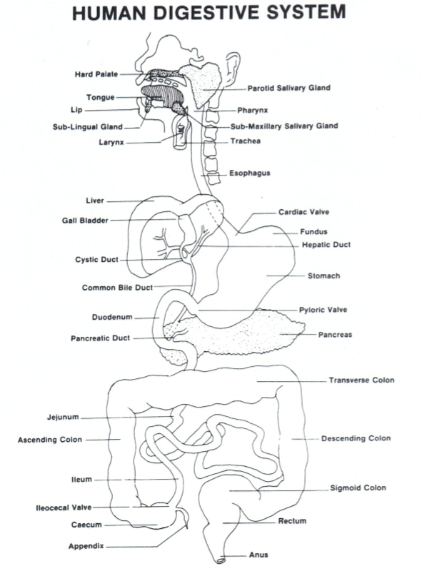
Tibialis Anterior
Diagram #5 - Superficial Muscles - Forelimb, Medial View
Clavobrachialis
Pectoanebrachialis
Epitrochlearis
Triceps Brachii

Part II - The Abdominal Cavity
The muscular diaphragm separates the upper from the lower ventral body cavity. The upper is the thoracic, the lower is the abdominal cavity.

With your fingertips locate the lower edges of the ribs. Your fingertips will be tracing an arc, an inverted letter “V”. Use your scalpel (knife) and cut the musculature along the line you traced.

After the muscle layers have been cut you will find a fine membrane, the peritoneum, which lines the inside of the abdominal cavity. The portion of this serous membrane that you see is the parietal peritoneum, the visceral peritoneum covers the abdominal viscera (internal organs) along the mid-ventral line from the V-cut to the pubic area. Then cut laterally toward the hind legs. Fold back the abdominal wall to expose the entire abdominal cavity.

Some specimens may contain excess preservative fluid, coagulated blood, or dye that has escaped from the blood vessels. In these cases it is first necessary to wash out the abdominal cavity. Hold the cat under a moderate water flow in the sink and rinse gently. Use paper towels to soak up excess water.

A double-layered sheet of peritoneum containing many fat deposits covers almost all of the abdominal organs below the liver. This apron-like membrane is known as the greater omentum.

Identify the following structures. Use the diagrams #6 -The Abdominal Cavity (Intact), #7 - The Abdominal Cavity (Greater Omentum Removed), and #8 - The Abdominal Cavity (Intestines Aside).
Diaphragm –This dome-shaped wall separates the thoracic from the abdominal cavity. You may have to cut a small part of the rib cage to expose it. To cut the ribs, cut just off center so you are cutting through the cartilage, which is easier. Three major vessels pass through the diaphragm between the thorax and the abdomen. These are the aorta, posterior vena cava, and the esophagus.
Liver – This dark brown organ dominates the upper abdomen. Five lobes can be seen: right lateral, right medial, left lateral, left medial and the cudate lobe.
Gall Bladder - This sac-like structure stores bile and releases it into the duodenum, the first part of the intestines, closest to the stomach. It is located in a depression on the dorsal surface of the right medial lobe.
Stomach – This muscular pouch lies on the left side in the upper abdomen under the liver. It is the continuation of the esophagus. Find the esophagus and locate where it pierces the diaphragm to join the stomach.
Extra - Open the stomach with your scissors by cutting along the greater curvature of the stomach, on the left side. Wash out the contents of the stomach. Note the cardiac sphincter which controls the entrance of food into the stomach from the esophagus. The pyloric sphincter at the posterior regulates the release of partially digested food (chyme) into the duodenum. Look along the inner walls of the stomach and note the rugae, or folds which help to churn and mix the food with the digestive juices.
Small intestine – The first portion of the small intesting is the duodenum. It is a continuation of the pyloric end of the stomach. It is a short “U” shaped tube, approximately four inches long. The common bile duct and the pancreatic duct open into the duodenum. The second section of the small intestine is the jejunum, which makes up about half the length of this organ. The ileum is the final section.
Extra – Open the jejunum or ileum, wash its contents and touch the inner surface with your fingertips. The velvety texture felt is due to the presence of numerous villi along the inner walls. Use a hand lens or dissection microscope to observe them more clearly.
The coils of the small intestine are held in place by a fine membrane, the mesentery. Note its shiny thin appearance. It is interlaced with narrow blood vessels, lymphatic vessels, adipose tissue and lymph nodes. Cut through the mesentery to unravel the small intestine. Measure its length. How does it compare to the relative length of man’s intestine (about twenty feet)?
Large Intestine – The end of the ileum projects into the caecum, the first segment of the large intestine, about a half inch above its origin. At the junction, the ileocecal sphincter valve will be found. Make a cut here and observe the valve. In man the appendix would be attached here. It is missing in the cat.
Pancreas – The pancreas is a flat elongated gland which lies between the duodenum and the spleen.
Spleen – This dark-colored organ lies to the left of the stomach, along its greater curvature.
Kidney – This reddish, brown bean-shaped organ lies embedded retroperitoneally, namely, behind the parietal peritoneum, in the dorsal body wall, one on each side. The adrenal gland is located near the anterior end of each kidney, but is separated from it and lies slightly medial of the kidney. In humans, the adrenal gland forms a “cap” upon the kidney.
Urinary Bladder – This oval-shaped organ lies at the ventro-posterior end of the abdominal pelvic region. It is suspended ventrally and laterally by suspensory ligaments.
Female – Use the diagram #9 - The Urogenital System - Female
Ovary – They are paired, small bean-shaped structures located posterior to the kidneys. The oviducts, or fallopian tubes, extremely narrow, usually located dorsal to the anterior portion of the ovary. Use a hand lens to observe them more closely. Also observe the expanded ends of the openings, the ostium, fringed by small finger-like projections that guide the ova from the ovary.
Uterus – Trace the oviducts to the longer uterine horns which join the uterus, which lies dorsal to the urinary bladder. In cats and other mammals, the fetus does not develop in the body of the uterus, as in man, but in the horns extending from the uterus. This permits the development of more fetuses at one time and the birth of a litter.
Male – Use the diagram #10 - The Urogenital System – Male
Testes – Locate the scrotum, the swollen double sac ventral to the anus. Carefully cut the skin of the scrotum. It is lined with peritoneum and divided into two compartments by a median septum. In the photo the left testis is shown in place and the right testis was placed upon the right thigh to facilitate observation.
Epididymis – This is an extensively coiled tubular structure lying on the dorsal surface of each testis. Follow the epididymis cranially. Its convoluted ducts are continuous with the duct that exits the scrotum into the abdominal cavity.
Ductus Deferens (Vans Deferens) – It is through this tube that sperm and seminal fluid leave the testes. It exits the scrotum into the abdominal cavity.

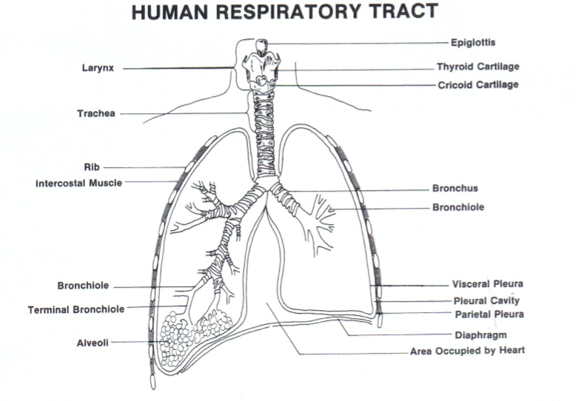
Part II – The Thoracic Cavity

Begin your dissection of the thoracic cavity by making an incision with your scissors at the base of the rib cage about a half inch to the right or left of the mid-ventral line. This will avoid hitting the bony sternum and you will be cutting across softer cartilage. Continue your incision until the top rib has been cut. Spread the rib cage. Cut each rib near its dorsal origin to open the rib cage maximally.

Identify the following structures using diagram #11 – The Thoracic Cavity
Diaphragm – This muscular sheet forms the floor of the thoracic cavity. Cut the diaphragm away from the body wall in a ventral to dorsal direction.
Pleural – This is the serous membrane found within the thorax. The parietal pleura lines the inner walls while the visceral pleura covers the organs of the thorax.
Lungs – In the cat the right lung is composed of four lobes, the left of only three. In man the right lung has three lobes, the left has only two. They feel spongy when alive and more rubbery in preserved specimens. Each lung lies within a separate pleural cavity, the space between the lung and the thoracic body wall.
Extra – Cut a small, flat section of lung and observe with a hand lens or dissection microscope. If your specimen has been doubly injected (arteries and veins) you should observe three types of vessels within the lung tissue:
- Pulmonary Artery – Branches of this vessel contain blue dye
- Pulmonary Vein – Branches of this blood vessel contain red dye
- Bronchioles – These branches of the bronchi, distributed throughout the lungs, are hollow with white edged wall
Trachea – This tube, the windpipe, extends along the mid-ventral portion of the neck extending into the thoracic cavity. Here it brances to form the two bronchi which penetrate the lungs. The air passage is always kept open by cartilage rings which stiffen and give a circular shape to the walls of the trachea. They are incomplete dorsally, thus forming the letter “C”. The trachea lies ventral to the esophagus.
Extra – With your scissors cut out a half inch section of the trachea. Observe the rings. Slit the section longitudinally along the ventral side. Observe with a hand lens.
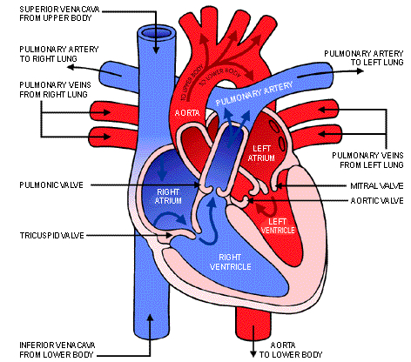
Larynx – This structure also known as the voice box is located at the top of the trachea. Its uppermost segment is the epiglottis. It is associated with the hyoid bone anteriorly.
Pericardium – This double membrane encloses the heart. The visceral pericardium adheres closest to the outer wall of the heart, while the parietal pericardium forms a sac which encloses the heart. It encloses the heart as well as the large blood vessels entering and leaving the heart. Fat tissue is embedded within it. The phrenic nerves which innervate the diaphragm pass along the lateral edges of the pericardium.
Extra – Inspect the heart and find the Vena Cava, pulmonary and Aorta
Vessels. Cut the heart open to view the atria (top), ventricles (bottom) and valves.

Part III – Nervous System – The Brain
Use a bone saw to make one mid-sagittal and several transverse cuts through the cranium. Use forceps and insert between the bone and the membranous covering of the brain. With the forceps break the loosened chips of the bone. Use extreme caution. Try to not damage the delicate brain tissue.

Expose the cerebrum as far anteriorly as the heavy bony ridges above the nose and laterally to the level of the eyes. Remove more cranial bones posteriorly to expose the cerebellum and medulla as well as the top of the spinal cord. A transverse bony septum (wall), the tentorium, lies between the cerebrum and cerebellum. Be very careful in removing it.

Remove the brain. You may have to use the probe to lift the brain. Look in the resulting cranial cavity and try to find the optic nerves leaving the eye cavities.

The brain is enclosed by three membranes collectively called the meninges. The outer, tough fibrous layer adheres closely to the inner surface of the bones of the cranium. It is called the dura mater. The delicate middle layer is the arachnoid. The thin inner membrane is called the pia mater and is highly vascular (many blood vessels present). This last layer follows the contours and convolutions of the brain and adheres closely to it. Carefully remove the dura mater. During this procedure the arachnoid is also generally removed.

Note the following structures. Use diagram #12 Sheep Brain (Dorsal View), #13 Sheep Brain (Ventral View) and #14 Sheep Brain (Sagittal View). The sheep brain is very similar to that of the cat and human.
Cerebral hemispheres – note the convoluted surface, sulci (depressions) and gyri (raised areas). The right and left hemispheres meet at the longitudinal cerebral fissure.
Cerebrum – contains the cerebral cortex, the basal ganglia and the limbic system
Cerebellum – at the base of the brain, involved in movement, attention, language, emotion among other things.
Medulla Oblongata - The medulla contains the cardiac, respiratory, vomiting and vasomotor centers and deals with autonomic functions, such as breathing, heart rate and blood pressure.
Corpus Callosum – To see this structure you have to make a mid-sagittal cut. The corpus callosum is a band of white fibrous tissue connecting the right and left halves of the brain. It forms a roof over the large lateral ventricles of the brain in which cerebrospinal fluid is found.

