In order to make sense of mitosis and meiosis one must have some basic chromosome terminology.
Duplicated Vs Unduplicated Chromosomes
Chromosomes either have one or two molecules of DNA plus associated proteins. A chromosome with one molecule of DNA is called an unduplicated chromosome because it only contains one molecule of DNA. On the other hand, a duplicated chromosome contains two identical daughter DNA molecules that have come from an original DNA molecule. Some texts refer to these as unreplicated Vs replicated respectively. In the case of a duplicated chromos ome, each molecule of DNA and associated proteins is called a sister chromatid.
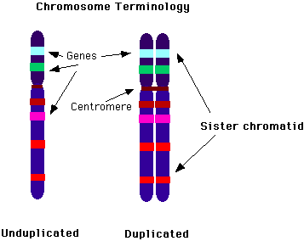
Chromatid vs. Chromosome
Remember that when two DNA molecules are joined together, each molecule is called a chromatid and the two of the molecules are called a duplicated chromosome. When a DNA molecule(and proteins) is not attached to another one then that single molecule of DNA is not a chromatid but an unduplicated chromosome.
Centromere
When a chromosome is examined during mitosis or meiosis there is a pinched in region somewhere along the length of the chromosome called the centromere. The centromere is a region to which the spindle fibers attach to the chromosome and it is in a characteristic position that is constant for different types of chromosomes. Thus the centromere is important for studying and identifying chromosomes. The centromere also contains a small ring of protein called a kinetochore which is important in the movement of chromosomes during mitosis and meiosis.
Telomere
The ends of the chromosome in eukaryotes are called telomeres. This region is important because during DNA replication, the telomere does not always get duplicated properly and the chromosome shortens slightly. The telomere contains many repeating sections of DNA rather than regions of DNA that code for specific genes.
Chromatin
During certain times of the cell's life cycle the chromosomes are not visible. This is because the chromosomes are stretched out very thin to allow surfaces for the various chemical reactions that involve chromosomes to take place. When the nucleus is stained and examined, it appears uniformly colored and the chromosomes collectively are termed chromatin. It is critical to remember that even though individual chromosomes can't be seen in the chromatin, the chromosomes still exist.
Homologous chromosomes
For meiosis it is critical to understand one other aspect about chromosomes. Namely that in most familiar organisms chromosomes come in identical looking pairs called homologous chromosomes. You may know that bits of DNA along the chromosomes determine characteristics of the organism, say eye color, hair texture etc. These bits of DNA are called genes. Homologous chromosomes have the same general kind of gene along their length but the details of the gene on one chromosome may be slightly different than the corresponding gene on the other chromosome. For instance, in a certain spot(usually called a locus) there may be a gene that codes for straight hair. At the same spot or locus on the homologous chromosome will also be a gene for hair texture but it might code for curly hair. Alternate forms of a gene are called alleles. 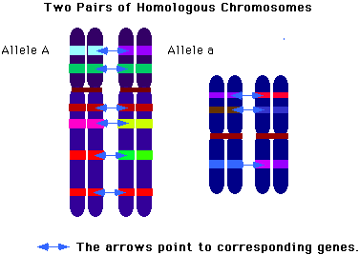
Autosomes Vs Sex Chromosomes
Some organisms such as birds and mammals have a chromosomal system of sex determination. For example in humans, individuals which have two X chromosomes (XX) typically develop into females and individuals which have an X chromosomes and a Y chromosome (XY) develop into males.
Autosome refers to those chromosomes that are not involved in sex determination. Human diploid cells have 22 pairs of autosomes and 1 pair of sex chromosomes.
Sex chromosomes are chromosomes involved in a major way in sex determination. No all species use the XY chromosome system that we use. For example, in birds the females are XY and the males are XX!
What is curious is the the X and Y chromosomes are not strictly homologous. For example since the X chromosome is much bigger than the Y chromosome, most of the genes on the X chromosome do not have corresponding genes on the Y chromosome.

http://staff.jccc.net/PDECELL/celldivision/chromoterm.html

