Your sill may be a window to the prehistoric world
Limestone in Chicago's windowsills and steps harbors a trove of prehistoric creatures

May 11, 2011|By Terry Gates, Special to the Tribune

Chicagoans do not have to venture to the grand halls of the Field Museum to study the fascinating ancient natural history of the Windy City. They simply need to look out their windows or walk down their front steps.

The large stone slabs that form the windowsills and front steps of many turn-of-the-20th-century homes and apartment buildings in Chicago are made of limestone, a rock that forms from the skeletons of ocean-dwelling animals. These rocks also contain fossils. Closely examining the limestone reveals pieces of animals that once lived in a shallow tropical reef when an ocean covered Illinois and Indiana 340 million years ago.

During this time, the Midwest was near the equator. Imagine a warm, tropical Caribbean beach in Chicago and, just offshore, a beautiful reef full of colorful animals. In addition to a wide variety of fish, you would have found an array of invertebrates including coral, brachiopods, sea fans and sea lilies.
All of these fossils are recognizable within the limestone around Chicago.

The sea fans are technically known as bryozoans. These animals live in groups of thousands that compose large structures to protect themselves and capture food. In fossil form, they are most often seen in the rock as a wide, gridlike structure or something akin to a small twig. Brachiopods look similar to clams but evolved from different ancestors. As opposed to clams that have mirror-image shells, brachiopods have shells that are two different shapes. Sea lilies, also called crinoids, are animals that look like stalked flowers but are actually related to starfish and sea urchins. In fossil form, crinoids can be identified by the circular plates that make up the stalks on their bodies, which are often protruding from the rock. Many other types of fossils can be found within these limestone slabs, but they are difficult to identify because of the huge number of animal skeletons packed into the rock. A single windowsill in a Chicago home may have thousands of animal shells within it, and a set of front steps may have millions of shells.

The way the fossils are preserved in the rock gives paleontologists clues to the animals' life 340 million years ago. On a reef, the most delicate animals live closer to shore, while the animals with stronger shells live farther out, closer to the breaking waves. Based on the delicate nature of the fossils within the limestone, it is apparent that these animals lived in calmer waters. Most recognizable within the limestone are series of diagonal lines arrayed across the stone slabs. These are original lines formed in the seabed by water flowing in one direction. The limestone shows tides flowing in and out of the reef, gathering pieces of seashells and aligning them in diagonal patterns. The larger the lines, the stronger the water current. In cases where opposite diagonal lines meet to form a herringbone pattern, that's a sign of successive tides ebbing and flowing through the reef 340 million years ago.

Another prominent feature of the limestone windowsills and stairs reveals a more threatening side to life in the ancient reef. Shallow crescents stacked upon one another tell stories of large storms brewing within the warm, shallow seas and then sweeping along the coast, decimating the reef ecosystems and burying the corals, sea fans, sea lilies and brachiopods.

Limestone from Indiana, classically called Bedford limestone, was the main source for building and

sculpting stone in Chicago residences during the late 19th and early 20th centuries. The fossils and other grains within the limestone are nearly all the same size, making this stone ideal for cutting and carving. Outside the Midwest, Bedford limestone has been used around the world including sites in the United States such as the Statue of Liberty, the Empire State Building and several monuments in Washington.

Examples such as the fossil-laden limestone adorning Chicago's homes illustrate the many connections between the ancient world and our modern society. We use the skeletons of sea animals to construct homes and businesses, monuments and memorials. From afar, we view our architecture on a grand scale, hoping it will last for generations. But if we look closer, at the true components of our efforts, we will see pieces of the earth that have existed for eons, beyond any human comprehension of time.

The Architectural Geology of Downtown Chicago
LET THE ADVENTURE BEGIN!!

Stop #1 Pittsfield Building 55 E Washington
How many different fossils can you find in this building? Draw them here…

Stop #2 The Carbide and Carbon Building 230 N Michigan
It has been said that this building is composed of “black marble.” If you look carefully, evidence of fossil snails can be found in this marble. Can you find any? What do they look like? Sketch them.

What does the word carbide mean?

Stop #3 Michigan Avenue Bridge The river and Michigan Ave
Find a fossil in the limestone of the bridge houses? Sketch what you find.

How do you think it got there?

The four pillars that support this bridge represent something significant---what? (Hint: on the Chicago flag there are four stars. These stars represent the same events.)

Stop #4 Tribune Building Northeast corner of Michigan Ave & the river
Modeled in Indiana limestone, the design is based on the Butter Tower of Rouen Cathedral, with delicate stone tracery and a fine collection of individualistic gargoyles. The medieval atmosphere is heightened by Colonel McCormick's collection of stones from famous buildings around the world. The limestones used for the Tower are fossiliferous: trilobites, brachiopods, mollusks, gastropods, sponges, and bryozoa have been identified so far. The Tribune Tower is a Chicago Landmark.
Find “your” rock – a rock that you find intriguing. What rock(s) did you choose?

Take a picture of your rock.

Stop #5 Intercontinental Hotel 505 N Michigan Ave
Look for the fossils around the entrance to the Intercontinental Hotel. Sketch what you find.

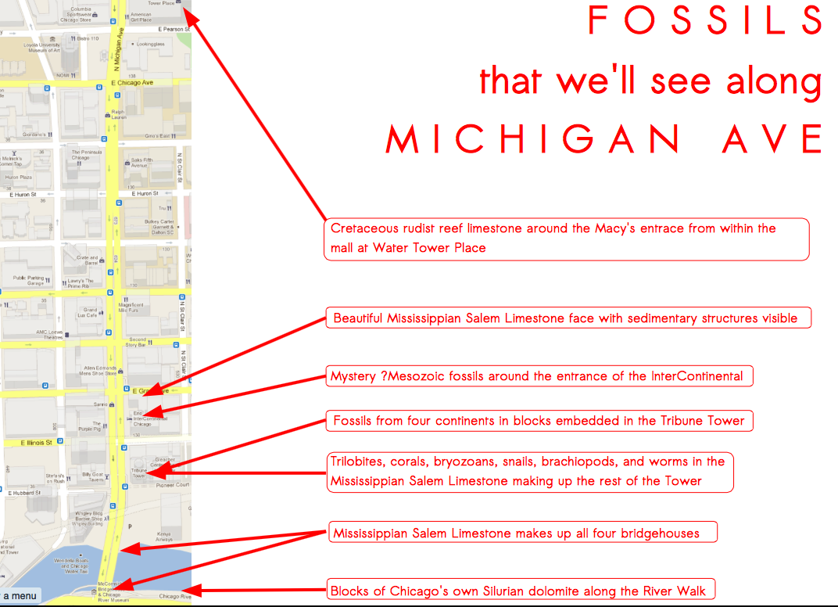

http://tinyurl.com/MichiganAveFossilsPDF

