Method to measure rate of photosynthesis

Each leaf disk contains air spaces and plant cells capable of performing photosynthesis. Plant cells need carbon dioxide (CO₂), water, and light to produce oxygen (O₂) and glucose through photosynthesis. You will be providing the leaf disks with carbon dioxide and water in the CO₂ solution. The light source will be a lamp provided by your instructor, or direct sunlight. The leaf disks are saturated with the CO₂ solution, which causes them to sink to the bottom. (Do not add leaves yet.) As the leaf disks are exposed to light they will perform photosynthesis, and therefore start producing oxygen and glucose. As the oxygen is produced, it will fill in the spaces in the leaf disk. Once enough oxygen has been produced, it will cause the leaf disk to float to the surface of the solution. Different types of plants have different rates of photosynthesis. By comparing how quickly the leaf disks float to the surface, we can infer which plant would have the faster rate of photosynthesis.

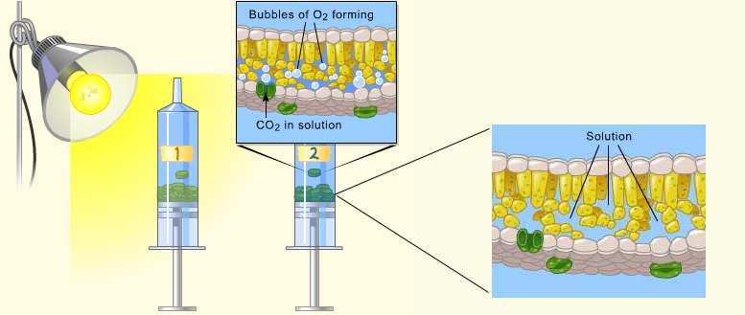

1. Obtain the following supplies for your lab team:
- 300 ml of 0.2% CO₂ solution (in a beaker)
- 3 plastic cups
- straw
- syringe
- paper towels
- timer

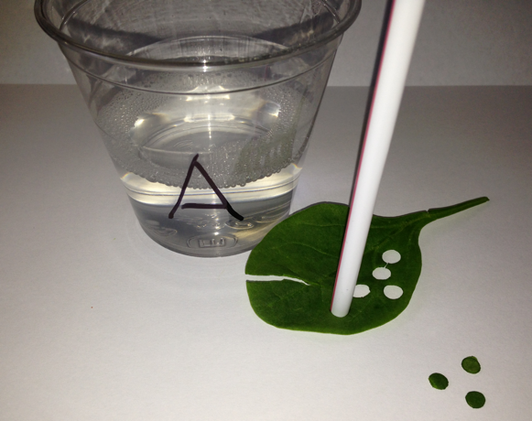
2. Your teacher has provided samples of different types of leaves from a variety of plants. Choose and collect leaves from 3 of the plant options. Hypothesize which leaf will undergo photosynthesis the fastest and record the type of leaf.

3. Label the plastic cups A, B, and C. Measure and pour 100 ml of CO₂ solution into each cup.

4. Place the leaves on paper towels. Use the end of the straw to cut out 10 small circles from each leaf. Try to stay away from any large veins in the leaf. Make sure each circle is whole and keep them in separate piles for each leaf type.

5. Remove the plunger from the syringe and gently place the 10 disks from leaf A into the syringe. Replace the plunger gently and push it until only a small amount of air and the leaf disks are left. DO NOT SMASH THE LEAF DISKS!

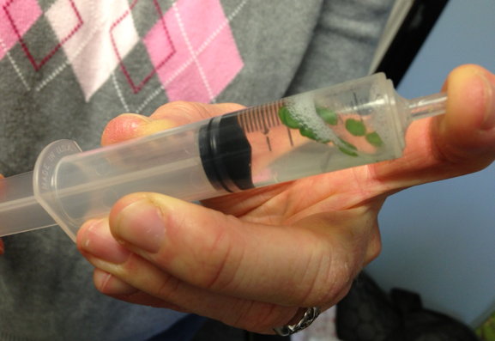
6. From cup A, pull approximately 3-5 ml of CO₂ solution into the syringe with the leaf disks.

7. Cover the opening of the syringe and lightly pull back the plunger to create a vacuum. Hold the vacuum for 10 seconds and then release it.
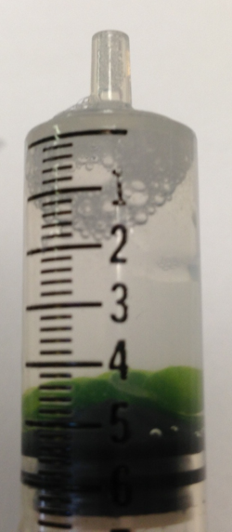
8. The vacuum will force the CO₂ solution into the air spaces of the leaf disks and the disks will float to the bottom of the syringe when they are full of CO₂ solution. You will have to repeat the vacuum and release a few times until all of the leaf disks remain at the bottom of the syringe.

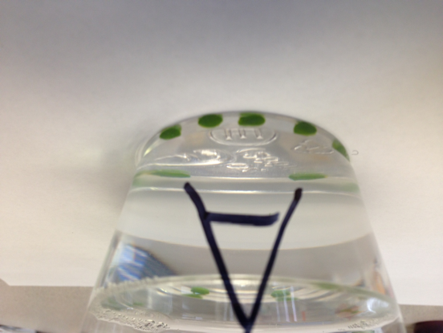
9. IF all of the disks have not sunk to the bottom after 4 vacuum attempts, add one drop of liquid soap to the solution in the syringe and repeat steps 4 and 5. Soap coats the surface of the leaf, allowing the CO₂ solution to be more easily pulled into the leaf.

10. Remove the plunger from the syringe and pour the leaf disks and solution into cup A.

11. The plant cells within each leaf disk are capable of performing photosynthesis and producing oxygen. The only things they need are CO₂, water, and light. You have provided CO₂ and water in the CO₂ solution. The only item you need now is the light source.

12. Your teacher may provide a lamp as the light source, or you can place the cup in direct sunlight. Take cup A to the light source. As soon as the cup is placed in the light source, start the timer.

13. As the plant cells perform photosynthesis, they produce sugar (glucose) and oxygen (O₂). As the O₂ is produced, it will push the CO₂ solution out of the spaces in the leaf. Once enough O₂ has been produced, it will make the leaf float to the top of the cup. The faster the leaf disks float to the top, the more photosynthesis is occurring.

