Name __________________________________________________________________ Cells
The links you will need for sections A, B, C and D are on our class webpage http://40two.info/barge/bio/cells.html

A. Use the Cells Alive Cell Organelle Animation link from our class website to identify the organelles in the plant and animal cells below. Click on the red phrase Take me to the ANIMATION.

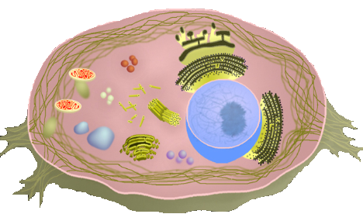

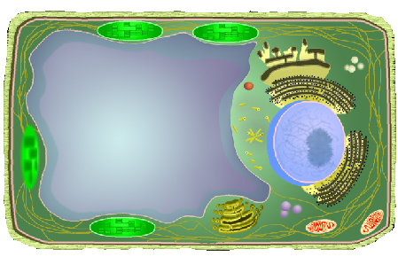

Eucaryotic Cell Organelles
Use the Cells Alive website to describe the organelles in the plant and animal cells below.

Nucleus:

Nucleiolus:

Cytosol:

Cytoplasm:

Centrosome:

Centriole:

Golgi:

Lysosome:

Peroxisome:

Secretory Vesicle:

Cell Membrane:

Mitochondria:

Vacuole:

Cell Wall:

Chloroplast:

Smooth Endoplasmic Reticulum:

Rough Endoplasmic Reticulum:

Ribosomes:

Cytoskeleton:

Procaryotic Cells
Use the Cells Alive website to identify and describe the organelles in the bacterial cell below.
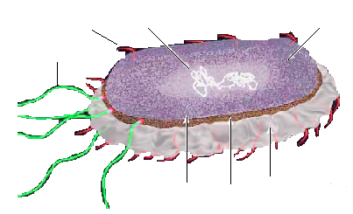

Internal Structure:

Nucleoid:

Ribosomes:

Storage granules:

Appendages:

Pili

Flagella

Surface Structure:

Capsule:

Outer membrane:

Cell wall:

Periplasmic space:

Plasma membrane:

B. Visit the Cell Structure Interactive link to review cell organelles & try to construct a cell.
Did you get it right the first time?
Animal
Plant
Prokaryotic

C. Take some time and browse through the Examples of Cells links. Which ones do you find interesting? Did you look at the movies under the Cells that move link? The Gallery of Cells link has many good images of organelle. In the space below, describe some of the links you found interesting. Explain why you think they are interesting.

D. Cell Lay-Off
The Cell Body Corporation has decided to eliminate several organelles due to budget constraints. You will be assigned an organelle (mitochondria, nucleus, lysosomes...) to research. You must write a letter to the Cell Body Corporation to convince them not to eliminate the job of your organelle. You must state the function of the organelle and explain how it works together with the rest of the cell. You must provide an image of your organelle (i.e. drawing of the cell, diagrams, etc) on 8x11 paper. You will read your letter to the Cell Body Corporation (your classmates). The corporation must determine whether the job of the organelle is important or not.

