Biology Energy Unit Study Guide
Energy storage
- What is meant by “energy flow” in a system

- How is energy stored in each of the following:
Kinetic energy

Gravitational energy

Chemical energy

Light energy

Heat energy

- What is the difference between a first-order, second-order and third-order consumer?

- Explain what a food chain is and give an example.

- Explain what a food web is and give an example.

- Use the diagram below to answer the following questions.
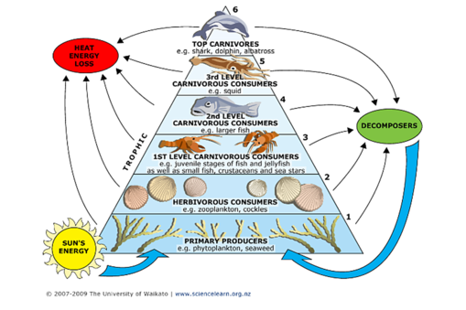
  - What is one food chain pictured?

  - What would happen if the zooplankton & cockles disappeared?

  - How does the available energy change as matter and energy move from the phytoplankton to the dolphin?

- What does the answer to question 6c above, say about energy flow and trophic levels in an ecosystem?
- Is the flow efficient, meaning most of the energy moves to the next level? (Think about the energy graphs in the worksheet Energy Exercise 1)

Digestion
- Explain what digestion is.

- Compare the digestion systems of the following:
Organism | Digestive Anatomy | Purpose
Earthworm

Grasshopper

Frog

Pig

Cellular Respiration
- Explain what cellular respiration is.

11. Write the equation for cellular respiration

12. What three processes are involved with cellular respiration & what do you get out of them?

13. Which cells and what kind of organisms do cellular respiration?

14. What is the difference between aerobic and anaerobic respiration?

15. Explain what fermentation is.

16. Write the equations for fermentation.

17. Why is ATP (adenosine triphosphate) so important?

Photosynthesis
17. Explain what photosynthesis is.

18. Write the equation for photosynthesis.

19. What is the difference between the light and dark reactions in photosynthesis?

20. Compare cellular respiration and photosynthesis.

