Student Activity: How To Make A Dichotomous Key
Keys used in the field by a biologist are used to identify organisms that already are classified. Dichotomous keys are designed to assist people with the identification of all types of living things from plants to microbes. The word dichotomous comes from dichotomy meaning branching, contrasting or opposite ideas. A dichotomous key gives you a series of steps with a set of choices, which are opposite or contrasting in nature. These are initially very general and become more specific as one proceeds through the steps. By analyzing the physical characteristics of the object/organism in question and using the steps and choices given in the key, the observer can identify an object/organism based upon established traits.

Making your own dichotomous key can be easily done for a group of living or nonliving things that you want to identify by physical traits. This can be a good method for helping people make observations and understand some physical traits that are important for learning how to classify things. Follow these basic rules when making a key and you are on your way:

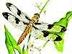
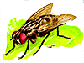
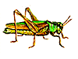
Start by observing the group of things to be used in the key. List the most general traits that can be used to divide the organisms into categories.

A Simple Example
Suppose you have four insects - a ladybug, a housefly, a dragonfly and a grasshopper. After studying the insects, you might use wings covering, body shape and where the wings point towards.

To begin the key, you could start separating the four insects based on wing covering - "wings covered by exoskeleton" vs. "wings not covered by exoskeleton."

The first step in the key will be organized the following way:

1. a. wings covered by an exoskeleton
b. wings not covered by an exoskeleton

Next, the statements need to lead the observer to the next step to narrow the identification further:

1. a. wings covered by an exoskeleton . . . . . . . go to step 2
b. wings not covered by an exoskeleton . . . . . . . go to step 3

Step 2 needs to consist of a pair of statements that will allow for the identification of the ladybug and the grasshopper:

2. a. body has a round shape . . . . . . . ladybug
b. body has an elongated shape . . . . . . . grasshopper

Step 3 needs to consist of a pair of statements that will allow for the identification of the housefly and dragonfly:

3. a. wings point out from the side of the body . . . . . . . dragongly
b. wings point to the posterior of the body . . . . . . . housefly

Notice that there were four organisms to be identified and it only took three steps. There should be one less step than the total number of organism to be identified in your dichotomous key.

If you follow this simple model you will be able to develop keys for many different things. The more similarities the group of things have, the more difficult it is to develop a key. For example, keys used to identify similar flowers will use traits like how the pollen grains are packaged!
How to make a dichotomous key

Another Example

First, create a blank flow chart. It should look like this:
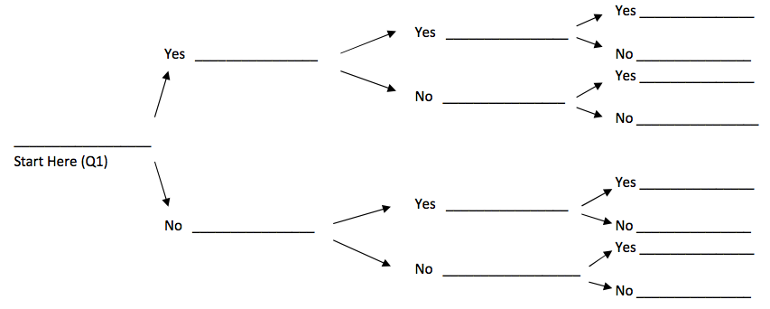
First, separate the objects into two separate piles based on one characteristic. For example, for a group of vegetables, you could separate them into two groups of all green vegetables and all NOT green vegetables. There does not have to be the same number in each group. Then, write your first question based on this separation. (Q1)

Next choose one of the groups and repeat. Divide it into two subgroups like you did with the large group.

Each division’s questions can only have two possibilities because it is a dichotomous key, di means “2”. Thinking in YES and NO questions can be helpful.

